Fast Brain Control Systems for Electric Wheelchair using Support Vector Machine

Widodo Budihartoª, Alexander Agung Santoso Gunawanª, Ivan Halim Parmonanganª, Jennifer Santosoª
ªSchool of Computer Science, Bina Nusantara University, Jakarta 11480, Indonesia

ABSTRACT
This paper proposes a technology which enables human brain to control the electronic wheelchair movement. We created software for tablet PC to process electroencephalography (EEG) data using Emotiv’s Software Development Kit (SDK). The main aim is to increase the accuracy rate of the brain control system by applying Support Vector Machine (SVM) as machine learning algorithm. EEG samples are taken from several respondent with disabilities but still have healthy brainto pick most suitable EEG channel which will be used as a proper learning input in order to simplify the computational complexity. The controller system based on Arduino microcontroller and combined with our software to control the wheel movement. The result of this research is a brain-controlled electric wheelchair with enhanced and optimized EEG classification.

Keywords: EEG, Neuroheadset, wheelchair, Emotiv, brain control systems, SVM

1.INTRODUCTION
In this era, biomedical assistive devices are quickly developed. The widespread purposes makes this field expand even faster. In this research, we are using the potential in each healthy-minded humans; brain. The brain is the central of body control which it handles our heartbeat, perspiration, mood, focus, and muscle movement. Prior research has shown that human brain activity can be seen through electroencephalograph (EEG) and blood flow in the brain. This activity can be seen with several technologies, such as MRI. These days, researchers has succeeded to use brain to interact with computers which known as Brain-Computer Interface (BCI).

According to Vallabhaneni, Wang, and He ^{[1]}, “Brain-computer interface (BCI) is a method of communicating based on neural activity generated by the brain and is independent of its normal output pathways of peripheral nerves and muscles.” BCI technology is a potentially powerful communication and provides interaction between users and systems beyond the keyboard ^{[2]}. Signal created from brain neurons is captured, processed, and converted as an instruction for computer system.

People with disabilities who have healthy brain are still able to use brain controlled wheelchair because they only need to use their mind to move around. Several studies have shown that both children and adults benefit substantially from access to a means of independent mobility ^{[14, 15]}. While the needs of many individuals with disabilities can be satisfied with traditional manual wheelchairs, a segment of the disabled community finds that it is difficult or impossible to use wheelchairs independently ^{[3]}. This will hinder the mobility of people with a total paralysis, who may still have normal brain functioning. Practically, the signal acquired by the EEG signal reader is raw EEG, which is noisy and full of artifacts such as Electromyograph (EMG), Electrooculograph (EOG), and Electrocardiograph (ECG), and also 50-60 Hz noise from electricity device hums, such as from transformers as shown in Figure 1. Those noise changes the amplitude and frequency of the pure EEG we want to obtain so that we have to filter all the noises to retrieve the purest possible EEG signals.
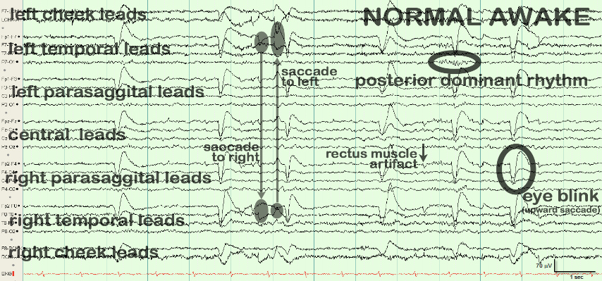
Figure 1. An image show raw EEG with noises^{[4]}

The main problem of BCI system is the complexity of brainwaves which makes the accuracy of classification is not that much satisfying. Some algorithms to interpret thought based on EEG signals have been developed. Cheng-Wen Ko proposed that a thought can be interpreted by detecting spike from EEG signal combined with neural network ^{[5]}. Another research developed by Itturate et al. suggest a way to stimulate thought through virtual reconstruction of the scenario, concentrate on the area of space to reach and finally controlling the navigation of electric wheelchair. However, in this research, each subject is required to concentrate continuously ^{[6]}. Rebsamen et al. developed wheelchair for Amyotrophic Lateral Sclerosis (ALS) patient in which the patient becomes paralyzed. They uses P300 and movement strategy navigation for their wheelchair which becomes more safe and efficient to be used inside a building ^{[9]}. Galan et al. proposed an asynchronous EEG-based BCI to control a wheelchair with 64 EEG channels ^{[10]}. However, this is practically useless for patients and not all of the channels are used as control signals, which means that the channels can be optimized.

This study aims to help quadriplegic patients, who have very limited mobility, to be able to use their mind to control the wheelchair on their own. There has been a similar study conducted in virtual reality ^{[16]}, but now the study is conducted in real condition. Since brain usage as a continuous control is exhausting for people, this study also have a purpose to optimize the brain control system on the wheelchair to minimize the effort exerted by the user to move the wheelchair. The optimization is done by finding appropriate commands to stimulate certain brain area. Our approach is to stimulate the brain with visual perception. Visual imagery and visual perception appear to engage frontal and parietal regions in more similar ways than occipital and temporal regions ^{[13]}. This finding may indicate that cognitive control processes function similarly in both imagery and perception.

Section 1 describes the background of the current condition and the introduction to the concepts of EEG, the main contribution of this study, as well as the problem statement, preliminaries, previous studies, and goal of the research. Section 2 explains our proposed method in solving this problem and a review of literature. Section 3 shows the analysis, process, and main result of the study. Section 4 concludes the study and explains further for future works.

2. MATERIALS AND METHODS
The wheelchair system consists of three main components. The first component is the neuroheadset to capture EEG signal from the subject. The second component is a software application to receive the captured EEG signal from the helmet, convert the signal as a command for the third component, which is a microcontroller with motors to control wheelchair movement.

In this research, we are using several key devices to support BCI and the electric wheelchair movement. Arduino UNO as the microcontroller operates two motors connected to the wheel of the wheelchair ^{[12]}. The interface we are using is Windows 7 or above installed tablet PC or laptop and the software is written in C# with Accord. NET Framework library for the Machine Learning libraries ^{[11]}. Meanwhile, the brainwave reader device we are using is Emotiv EPOC+, which is the newer version of the previous Emotiv EPOC that are bundled with extra libraries to retrieve raw EEG data from the device. Emotiv EPOC / EPOC+ features 14 EEG channels plus 2 references offering optimal positioning for accurate spatial resolution. Channel names, which are based on the international 10-20 electrode location system are AF3, F7, F3, FC5, T7, P7, O1, O2, P8, T8, FC6, F4, F8, AF4, with CM S/DRL references in the P3/P4 locations. Since this study uses raw EEG data, we have to do all the hard work to filter the raw EEG into pure EEG signal with digital signal processing and SVM. Figure 2 shows the image of Emotiv EPOC+ headset and the 14 channels of EEG.
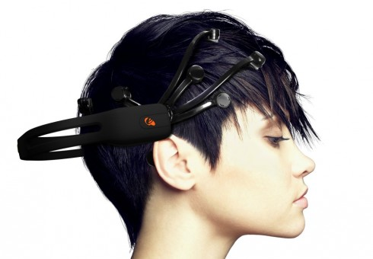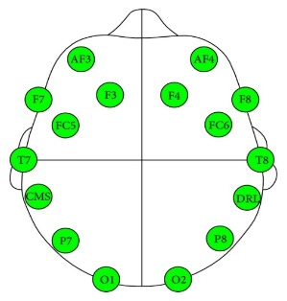
Figure 2. An image of Emotiv EPOC+ Headset and node placement ^{[7]}
The brainwave we are using in this project is alpha and beta. The alpha wave represents relaxed activity, whereas low amplitude beta waves with multiple and varying frequencies are often associated with active, busy, or anxious thinking and active concentration ^{[17]}. Therefore captured EEG is to be filtered using Bandpass Filter ^{[18]} to keep in the desired frequencies of alpha and beta waves (8 – 31 Hz). The result of this is a filtered EEG which lies in between of the passbands, while the EEG that are outside the passbands are to be treated as no signal at all.

Afterwards, the filtered EEG is then applied to windowing function ^{[19]}, which convolutes non-periodic EEG signal into periodic signal to minimize spectrum leaks when applying FFT (Fast Fourier Transform). The FFT operates by decomposing an N point time domain signal into N time domain signals each composed of a single point. The second step is to calculate the N frequency spectra corresponding to these N time domain signals. Lastly, the N spectra are synthesized into a single frequency spectrum ^{[20]}. FFT itself is used to extract frequencies in EEG samples used for SVM input.

2.1. Support Vector Machine (SVM)
Support Vector Machine, in general, clusters the data and creates a hyperplane that divides input data into classes we desired. SVM is used to construct the optimal hyperplane with largest margin for separating data between two groups. According to Bhuvaneswari ^{[8]}, Support Vector Machine techniques can be classified to three types: linearly separable, linearly inseparable, and nonlinearly separable. SVM is used to construct the optimal hyperplane with largest margin for separating data between two groups. For two dimensional data, single hyperplane is enough to separate the data into two groups such as +1 or -1.

Linearly separable classification separates the high dimensional data into two groups without any overlapping or misclassification. The two hyperplanes can be described by equations
$w.x - b =1$ (1)
$w.x - b = -1$ (2)

where w is the position of the hyperplane and x are data points, and b can be +1, 0, or -1 as bias value. By using geometrical calculation, we obtain the maximum distance between the two hyperplanes as $\frac{2}{\left\|w\right\|}$, while $\left\|w\right\|$is subject to constraint
$y\left(w ∙x-b\right)≥1$$y\left(w ∙x-b\right)≥1$$y\left(w ∙x-b\right)≥1$ $y\left(w ∙x-b\right)≥1$ (3)
Since this problem is difficult to solve by primitive ways, Lagrange multipliers are applied for to calculate the value. The Lagrangian multiplier for primal problem is as shown below:
$L\left(w,b,a\right)=\frac{1}{2}{\left\|w\right\|}^{2}-\sum_{i=1}^{n}{a_{i}\left[y_{i}w^{'}x_{i}+b\right]-1}$ (4)
where $a_{i}$is the Lagrangian multiplier. Applying derivative of L with respect to w and b yields:
$∀w L\left(w,b,a\right)=w-\sum_{i=1}^{n}{a_{i}y_{i}x_{i}}$ (5)

which implies that
$w=\sum_{i=1}^{n}{a_{i}y_{i}x_{i}}$ (6)

By applying this to Lagrangian multiplier for primal problem, we have
$L\left(w,b,a\right)=\sum_{i=1}^{n}{a_{i}}-\frac{1}{2}\sum_{i,j=1}^{n}{{y_{i}y_{j}a}_{i}a_{j}x_{i}'x_{j}}=\max{L(a)}$ (7)

The optimum separating hyperplane (OSH) can be calculated by quadratic programming (QP), while support vectors can gain value of $a$ and help obtaining bias value $b$ for training samples
$b= \frac{1}{n_{sv}}\sum_{sv∈S}{\left[y_{sv}-\sum_{i∈S}{a_{i}y_{i}x_{i}x_{sv}}\right]}$ (8)

And optimal decision function of a classifier is defined as
$f\left(y\right)=sign\left(\sum_{i=0}^{sv}{a_{i}y_{i}\left(x_{i},x_{sv}\right)+b}\right)$ (9)

Block diagram of the system is shown in Figure 3. As depicted, the system has several parts, comprising of hardware and software (application). The hardware part of the system is made up from wheelchair, microcontroller, motor and Emotiv EPOC headset. The application is done with C# and Emotiv SDK, and later with Arduino code, along with some libraries such as BasicDSP to handle EEG processing with bandpass filter, windowing, and Fast Fourier Transform (FFT). Also, we use Accord .NET to handle the training method that we use (SVM) for processed EEG.
Figure 3. Block diagram of the system
The software uses multi-threading feature to do the classification of P8 and F3 independently. The preprocessed EEG is collected and inputted into SVM classifier continuously. The output is then collected and compared to the sensitivity. This process will give user a new experience that their focus is easily adjusted by changing the sensitivity control of each action. The P8 classification runs only when it is in neutral mode. Once the mode is changed into forward, the classification stops and user will no longer need to focus. To change back into neutral mode, user only need to blink either left or right eye. The F3 classification runs continuously after it has been trained or loaded.
The software also has a sensitivity control to ease user at maintaining their focus. The experiment will be done twice, with sensitivity adjusted and not adjusted. Meanwhile, the pseudocodes for the preprocessing, P8 classification and F3 classification can be seen below.
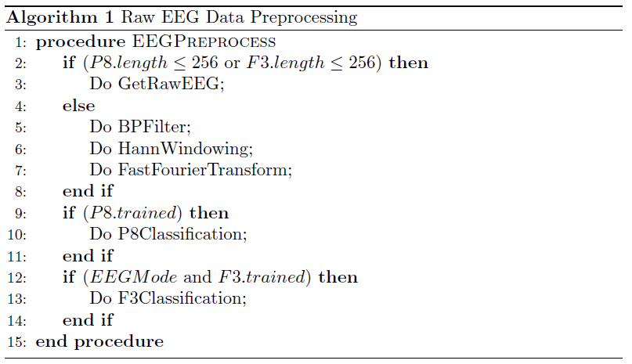
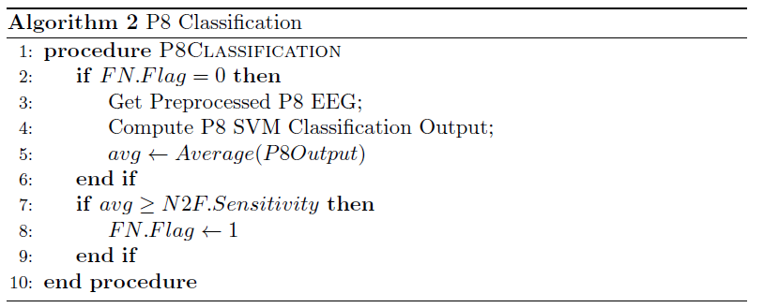
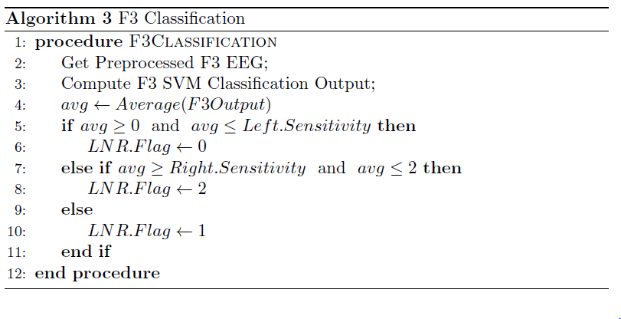

3. RESULTS AND DISCUSSION
Our experiment shows that the brain activity is very distinguishable in parietal and frontal area as stated by Ganis[13]. The data from those channels are good input for SVM that it could be separated linearly.The recording shows parietal and frontal lobe activities are easily separable which is good for machine learning input. To be precise, right parietal lobe is suitable for forward command and left frontal lobe is suitable for left-right command. Figure 4a and Figure 4b shows the preprocessed, frequency-based EEG sample of the channels that best fit, P8 for forward command and F3 for left-right command.
Figure 4a. EEG Sample for Neutral-Forward Command from channel P8
Figure 4b. EEG Sample for Directional Command (Left – Straight – Right) from channel F3

Figure 5 shows the application interface. As we can see, there are indicators such as “sample recorded” number in activity log, and label F (Forward) turns green indicates the subject is thinking to go forward.

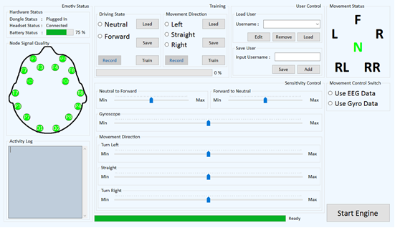
Figure 5. Main form running
Figure 6 show a wheelchair with brain control system and SVM that successfully running.

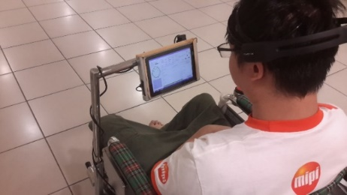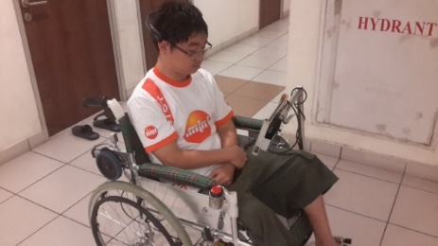
Figure 6. Wheelchair with Brain Control System and SVM
The experiment is done to five subjects, each of different ages, genders, and physical disabilities excluding the brain. The five subjects are to test each command (move forward, move left, move right and stop) for 10 times randomly. To move forward, subjects imagine an object or focus at a point in front of them and imagine that object come closer. Whereas to move left or right in EEG mode, subjects determine the direction they want to go and focus at some object on the direction they want to move. Finally, to stop the wheelchair, subjects could just blink either left or right eye.

The result of this experiment is counted from the number of true positive result from 10 tries per each movement. Tables below shows the results of the experiments without sensitivity adjustment:

Subject | Actions |  |  |  | Overall
 | Forward | Stop | Left | Right
1 | 9 | 8 | 8 | 7
2 | 8 | 7 | 9 | 8
3 | 9 | 10 | 7 | 8
4 | 7 | 9 | 7 | 9
5 | 10 | 9 | 8 | 9
Average | 8.6 | 8.6 | 7.8 | 8.2 | 8.3
Table 1. Result of experiment without sensitivity adjustment

The following table shows the experiment result with the same five subjects and the same random command procedure as before with the sensitivity adjusted:

Subject | Actions |  |  |  | Overall
 | Forward | Stop | Left | Right
1 | 9 | 8 | 8 | 8
2 | 9 | 8 | 9 | 8
3 | 9 | 10 | 8 | 9
4 | 8 | 9 | 7 | 8
5 | 10 | 9 | 9 | 9
Average | 9 | 8.8 | 8.2 | 8.4 | 8.6
Table 2. Result of experiment without sensitivity adjustment

4. CONCLUSIONS
Based on the current result, EEG signal is successfully captured by Emotiv and processed by applying Bandpass filter, Hann Windowing, and Fast Fourier Transform, making BCI implementation adequate. Out of 14 EEG channels in Emotiv EPOC, P8 is the most significant channel for which data can be used neutral to forward classification, while F3 is the most significant channel for directional classification (left, right, and neutral). There are some others like F5, F8, FC6, T7, and P7, but during the tests, P8 gave the best performance over the rest for neutral/forward classification, and F3 for the directional classification. The accuracy of the detection by SVM is 83% without sensitivity adjustment and 86% with sensitivity adjustment. This proves that using parietal and frontal lobe with visual perception gives a good result. The result also affected the user’s ability to learn the new system. The longer the user use the system resulting in the user accustomed to the system, the better the result.

Future research would include testing more of other channel’s performance and commands and therefore can be used as alternative for P8 and F3 whenever the subject has problems with the brain part associated with those two EEG channels that also opens a door to another usage of BCI. Possible further research would also include using optimized machine learning algorithm to increase accuracy of command classifications further.

ACKNOWLEDGEMENT
This work is fully supported by Toray Science and Technology Research Grant 2014-Japan.

REFERENCES
- Vallabhaneni, A., Wang, T., and He, B., “Brain-Computer Interface”. Neural Engineering, 85-121. doi:10.1007/0-306-48610-5_3 (2005)
- Erp, V. J., Lotte,Tangermann, F. and Tangermann, M., “Brain-Computer Interfaces for Non-Medical Applications: How to Move Forward”. IEEE Computer Society, 26-34. doi:10.1109/MC.2012.107 (2012)
- Simpson, and Richard, C., “Smart Wheelchairs: A Literature Review”, Journal of Rehabilitation Research & Development, 423-436(2005).
- http://EEGatlas-online.com/index.php/EEG-archive/EEG0001
- Ko, C. W, Lin, Y. D., Chung, H.W.,and Jan, G. J., “An EEG spike detection algorithm using artificial neural network with multi-channel correlation”, Proceedings of the 20th Annual International Conference of Engineering in Medicine and Biology 4, 2070-2073, (1998).
- Iturrate, I., Antelis, J., Minguez, J. and Minguez, J., “Synchronous EEG brain-actuated wheelchair with automated navigation", IEEE International Conference on Robotics and Automation, 2318-2325, (2009).
- Emotiv. http://www.emotiv.com (2015)
- Bhuvaneswari, P.,“Support Vector Machine for EEG Signals”, International Journal of Computer Applications 63, 0975-8887, (2013).
- Rebsamen, B., Teo, C. L., Zeng, Q., Ang, V. M. H., Burdet, E., Guan, C., Zhang, H., and Laugier, C., “Controlling a wheelchair indoors using thought”, IEEE Intelligent Systems22(2), 18-24, (2007).
- Gal’an, F., Nuttin, M., Lew, E., Ferrez, P. W., Vanacker, G., Phillips, J. and Mill’an, J. d. R., “A brain actuated wheelchair: Asynchronous and non-invasive brain-computer interfaces for continuous control of robots”, Clinical Neurophysiology 119, 2159-2169(2008)
- Accord.NET Framework. http://accord-framework.net (2015)
- Arduino UNO. http://arduino.cc/en/Main/ArduinoBoardUno (2015)
- Ganis, G., Thompson, W. L., and Kosslyn, S. M.,“Brain areas underlying visual mental imagery and visual perception: an fMRI study”, Cognitive Brain Res. 20, 226–241. doi:10.1016/j.cogbrainres.2004.02.012. pmid:15183394 (2004)
- Bourke, T., “Development of mobile wheelchair”,University of Wollongong, Thesis, 01-03, (2001)
- Tefft, D., Guerette, P., and Furumasu, J., “Cognitive predictors of young children’s readiness for powered mobility”, Development Medicine & Child Neurology 41(10), 665-670, (1999)
- Leeb, R., Friedman, D., Muller-Putz, G.,Scherer, R., Slater, M., and Pfurtscheller, G., “Self-paced (Asynchronous) BCI Control of a Wheelchair in Virtual Environments: A Case Study with Tetraplegic”, Computational Intelligence and Neuroscience 2007, 79642, (2007)
- Baumeister, J.,Barthel, T., Geiss,K. R., and Weiss,M., “Influence of phosphatidylserine on cognitive performance and cortical activity after induced stress”,Nutritional Neuroscience11 (3), 103-110, doi:10.1179/147683008X301478. PMID 18616866.
- Shenoi, B. A.,“Introduction to Digital Signal Processing and Filter Design”, John Wiley and Sons, (2006)
- Podder, P., Khan, T. Z., Khan,M. H., and Rahman,M.,“Comparative Performance Analysis of Hamming, Hanning, and Blackman Window”, International Journal on Computer Applications, 96 (18), (2014)
- Loan, C. V., “Computational Frameworks for the Fast Fourier Transform”, SIAM, 1982

