Speed Control Of Three Phase Induction Motor By Employing Sepic Converter

Abstract
This project is used to control the speed of three phase induction motor by employing sepic converter. The sepic converter is used to boost the input voltage. The boosted dc voltage is applied to the three phase inverter. This three phase VSI operates at 120 degree mode of operation. Three phase induction motor speed depends on the frequency of inverter.
Introduction
This project is mainly used for renewable energy source like solar, wind etc. The solarconverts the sunlight directly into electricity. That voltage range is low, so that low voltage is boosted by using the converter circuits. Converter is used to convert the low voltage dc into high voltage dc. Solar energy is involved in power plants, homes made appliances, ventilation systems, commercial appliances, solar lighting, cars and other remote applications where transmission and distribution is done.
Proposed System
The sepic converter has two inductors and one power devices for boosting the input voltage. If the power device duty cycle is varying the output voltage of the converter is varied. The converter output dc voltage is applied to the three phase inverter circuit. It converts the dc voltage into three phase ac voltage to drive the three phase induction motor. The PIC controller has key function for controlling the speed of the induction motor.
Block Diagram
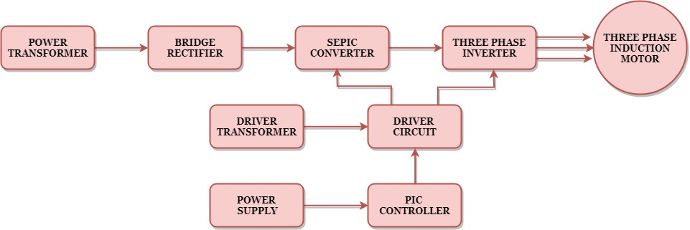

Block Diagram Explanation
- Pulse generator: - Here we have used PIC microcontroller (PIC 16F877a) to generate PWM signal.
- Driver circuit: It is used to amplify the pulses and provided isolations using opto coupler. It has two functions,
- Amplification
- Isolation
- Bridge Rectifier: It converts AC supply to DC Supply.
- SEPIC converter: It converts low voltage DC to high voltage DC supply.
- Three PhaseInverter: It converts DC supply tothree phase AC Supply to drive the three phase induction motor.

Driver Board
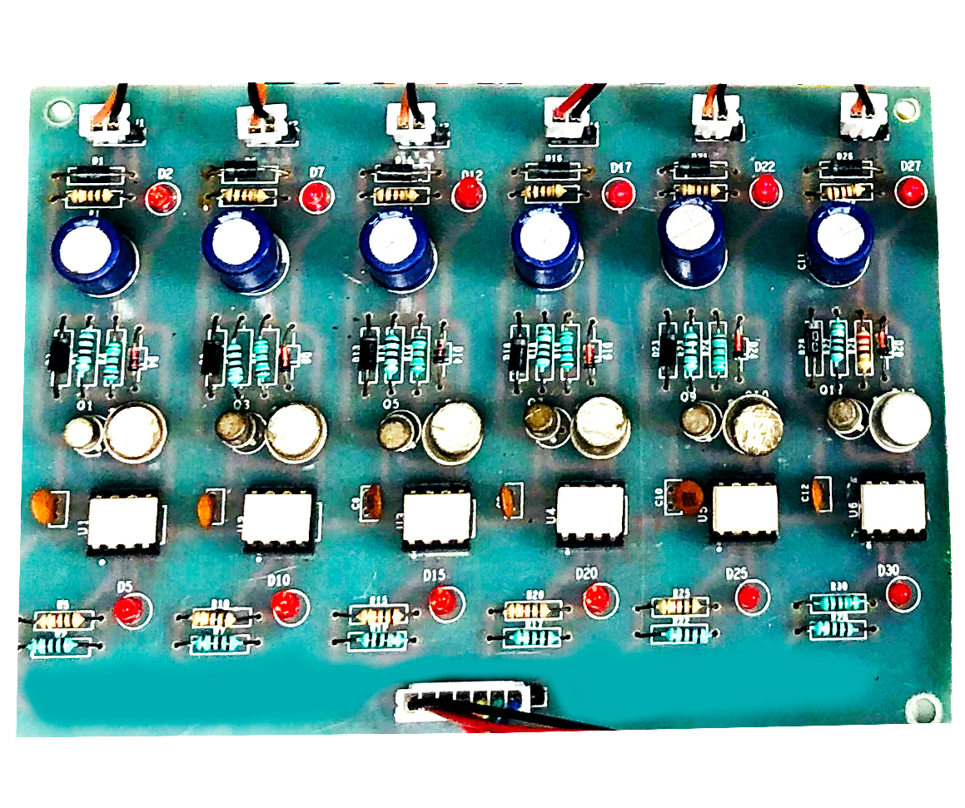
Pic Controller Board
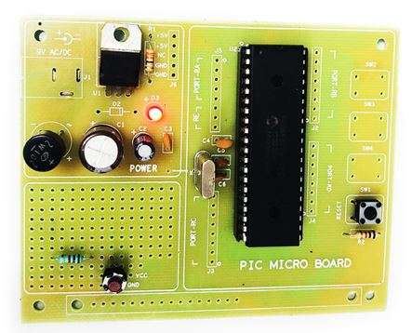
Working
The PIC controller is used to generate the PWM pulses for converter and inverter circuit. The PIC controller pulses are given to the driver circuit as input. Driver board is mainly used to isolate and amplify the input signals from the controller. The amplified driver output is connected to the main power circuit devices. The ac supply is converted into dc by using bridge rectifier. And the dc voltage is boosted by using sepic converter. The boosted dc voltage is applied to inverter circuit and by varying the frequency of the inverter the motor speed also varied.
Circuit Diagram For Sepic Converter
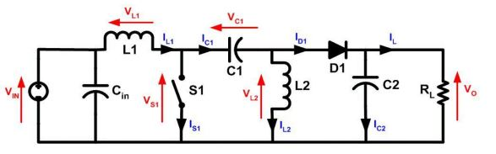
Circuit Diagram For Three Phase Inverter
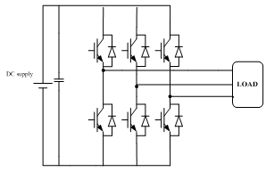
Advantages
- High efficiency
- Easy to control the speed
- Switching losses are reduced
Applications
- Industrial applications
- Pumping system
Conclusion
The speed control of three phase induction motor by employing sepic converter is mainly used to convert the low voltage sources to useful voltage source. The solar voltage produced is low voltage and thesepic converter is used to boost the low voltage and applied the dc voltage to three phase inverter circuit. So that low voltage solar energy is used to control the induction motor speed.

Output Waveform For Sepic Converter

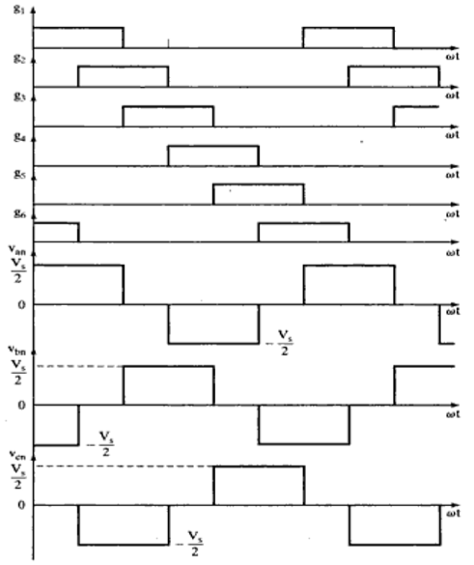
Three Phase Inverter Pattern

