SPEED CONTROL OF BLDC MOTOR BY EMPLOYING ZETA CONVERTER
ABSTRACT
This project is mainly used to control the speed of the bldc motor by employing zeta converter. The zeta converter is used step up the input dc voltage. The zeta converter output voltage depends on the duty cycle of the converter.The BLDC motor has high reliability, high efficiency high torque/inertia ratio, improved cooling, low radio frequency interference, low noise and requires practically no maintenance.

INTRODUCTION
The zeta converter exhibits the advantages over the conventional buck, boost, buck–boost and Cuk converters when employed in SPV-based applications. The zeta converter dc voltage is applied to three phase inverter circuit. Three phase inverter converts the dc voltage into three phase ac voltage. The zeta converter operates either increasing or decreasing the output voltage.

PROPOSED SYSTEM
This project is proposed to control the speed of bldc motor by employing zeta converter. The AC supply is applied to the bridge rectifier, the bridge rectifier converts ac supply into dc supply. That dc voltage is applied to zeta converter, the zeta converter boost the input voltage (i.e) if input 15v dc means zeta converter output voltage is greater than 15v dc voltage. That dc voltage is given to the three phase inverter,it converts the dc voltage into three phase ac voltage. Three phase ac voltage is connected to the BLDC motor. The bldc motor have hall sensor. The hall sensor output is feedback to the controller. The three phase inverter PWM depends on the hall sensor of bldc motor.The DSPIC controller key functions are used to control the bldc motor speed.
BLOCK DIAGRAM
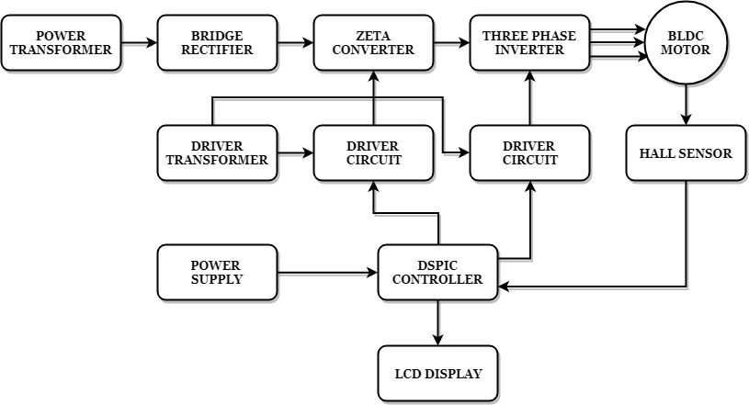

BLOCK DIAGRAM EXPLANATION
- Pulse generator: - Here we have used DSPIC microcontroller (DSPIC 30F4011) to generate PWM signals.
- Driver circuit: -It is used to amplify the pulses and provided isolations using opto coupler. It has two functions,
- Isolation
- Amplification
- Bridge Rectifier: It converts AC to DC Supply.
- ZETA converter: It convertslow voltage DC to high voltage DC supply.
- Three phaseInverter: It is used to convert DC tothree phase AC Supply.

DRIVER BOARD
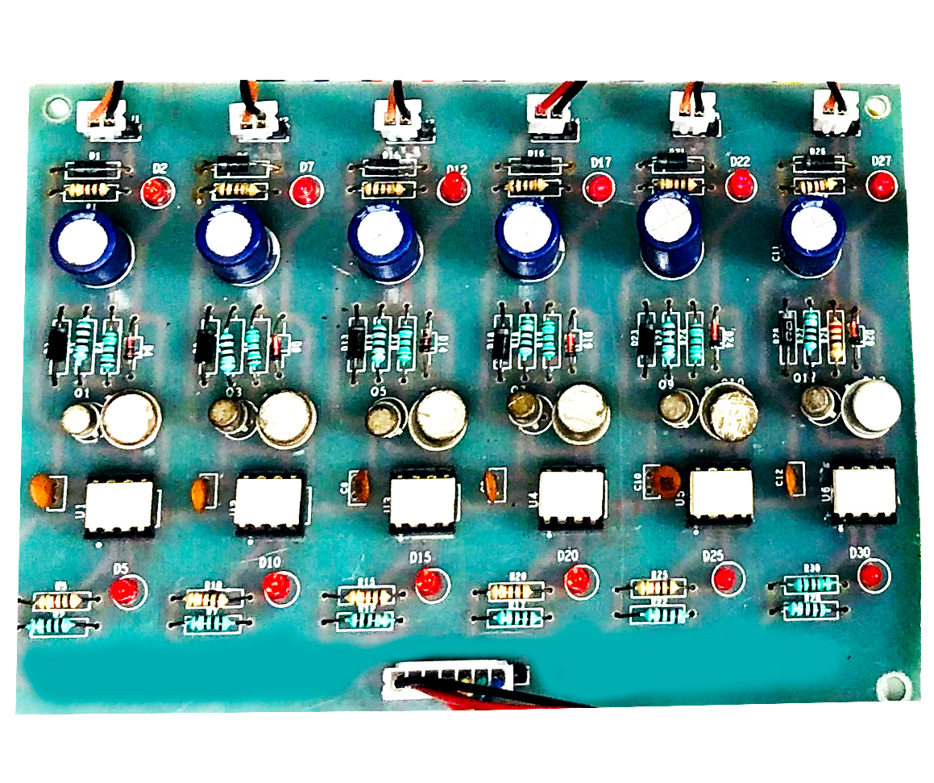
Dspic Controller Board
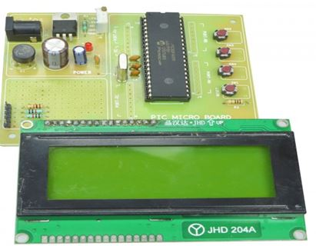
WORKING
The DSPIC controller is used to generate the pwm pulses for converter and inverter circuit. The DSPIC controller pulses are given to the driver circuit as input. Driver board is mainly used to isolate and amplify the input signalsfrom the controller. The amplifieddriver output is connected to the main power circuit devices. The duty cycle applied to thezeta converter to vary the output voltage. Three phase inverter PWM is generated based on Hall sensor feedback.
The speed of the motor is controlled by PI control technique. To control the speed, the PWM generated for three phase inverter duty cycle is controlled based on set speed.

CIRCUIT DIAGRAM FOR ZETA CONVERTER WITH INVERTER
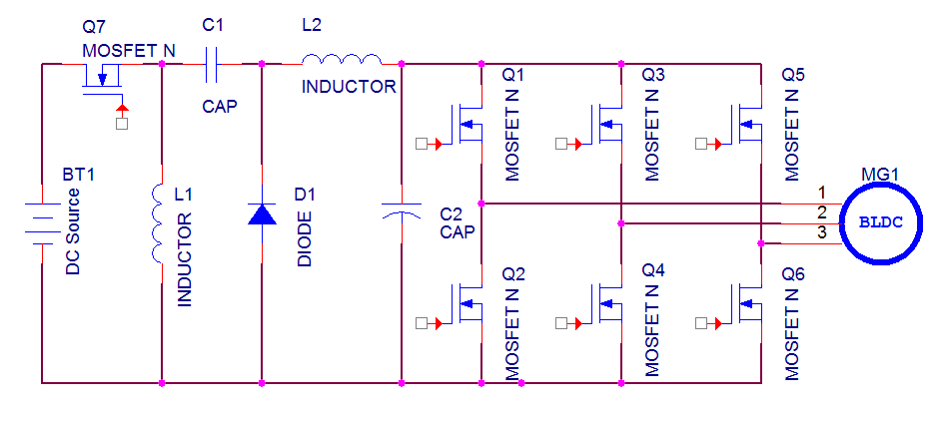

Advantages
- Easy to control speed
- Highly reliable
- High efficiency and less maintenance
- Less noise
Applications
- Water pump control
- Industrial applications

Conclusion
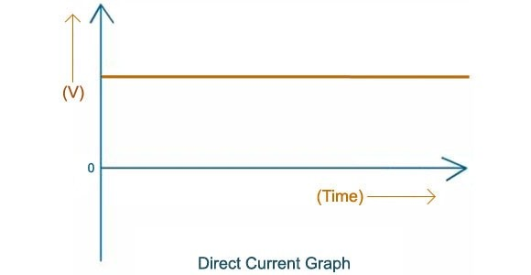
This project is control the speed of the bldc motor by employing zeta converter and three phase inverter. This inverter has low switching losses and bldc motor control without any additional control. And also study the response of the all characteristics and theory. This project is highly reliable and obtains high efficiency of this control technique. Output Waveform For Zeta Converter

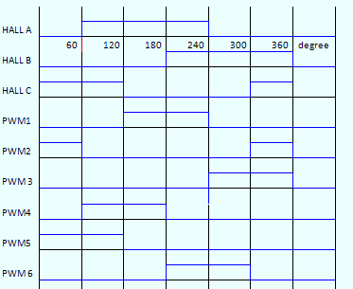
BLDC MOTOR WORKING PATTERN

