Speed Control Of Bldc Motor By Employing Sepic Converter

Abstract
This project is mainly used to control the speed of the BLDC motor by employing SEPIC converter. The SEPIC converter is used to step up the input dc voltage. TheSEPIC converter output voltage depends on the duty cycle of the converter.The BLDC motor has high reliability, high efficiency high torque/inertia ratio, improved cooling, low radio frequency interference, and noise and requires practically no maintenance.
Introduction
The SEPIC converter exhibits the advantages over the conventional buck, SEPIC, buck–boost and Cuk converter when employed in SPV-based applications. The SEPIC converter dc voltage is applied to three phase inverter circuit. Three phase inverter converts the dc voltage into three phase ac voltage. The SEPIC converter operates to increase the output voltage.
Proposed System
This project is proposed to control the speed of BLDC motor by employing SEPIC converter. The AC supply is applied to the bridge rectifier, the bridge rectifier converts ac supply into dc supply. That dc supply is applied to SEPIC converter, the SEPIC converter is SEPIC the input voltage (i.e.) if input 15v dc means SEPIC converter output voltage is greater than 15v dc voltage. That dc voltage is given to the three phase inverter; it converts the dc voltage into three phase ac voltage. Three phase ac voltage is connected to the BLDC motor. The bldc motor have hall sensor.
The hall sensor output is feedback to the controller. The three phase inverter Pulse depends on the hall sensor of bldc motor.The DSPIC controller key functions are used to control the bldc motor speed.
Block Diagram
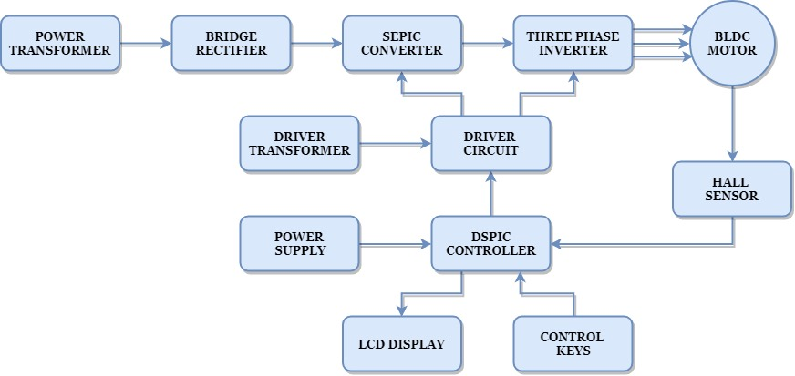

Block Diagram Explanation
- Pulse generator: - Here we have used DSPIC microcontroller (DSPIC 30F4011) to generate PWM signal.
- Driver circuit: -It is used to amplify the pulses and provided isolations using opto coupler. It has two functions,
- Amplification
- Isolation
- Bridge Rectifier: It converts AC supply to DC Supply.
- SEPICconverter: It converts low voltage DC to high voltage DC supply.
- Three phase Inverter: It converts DC supplyintothree phase AC Supply to drive the BLDC motor.

Driver Board
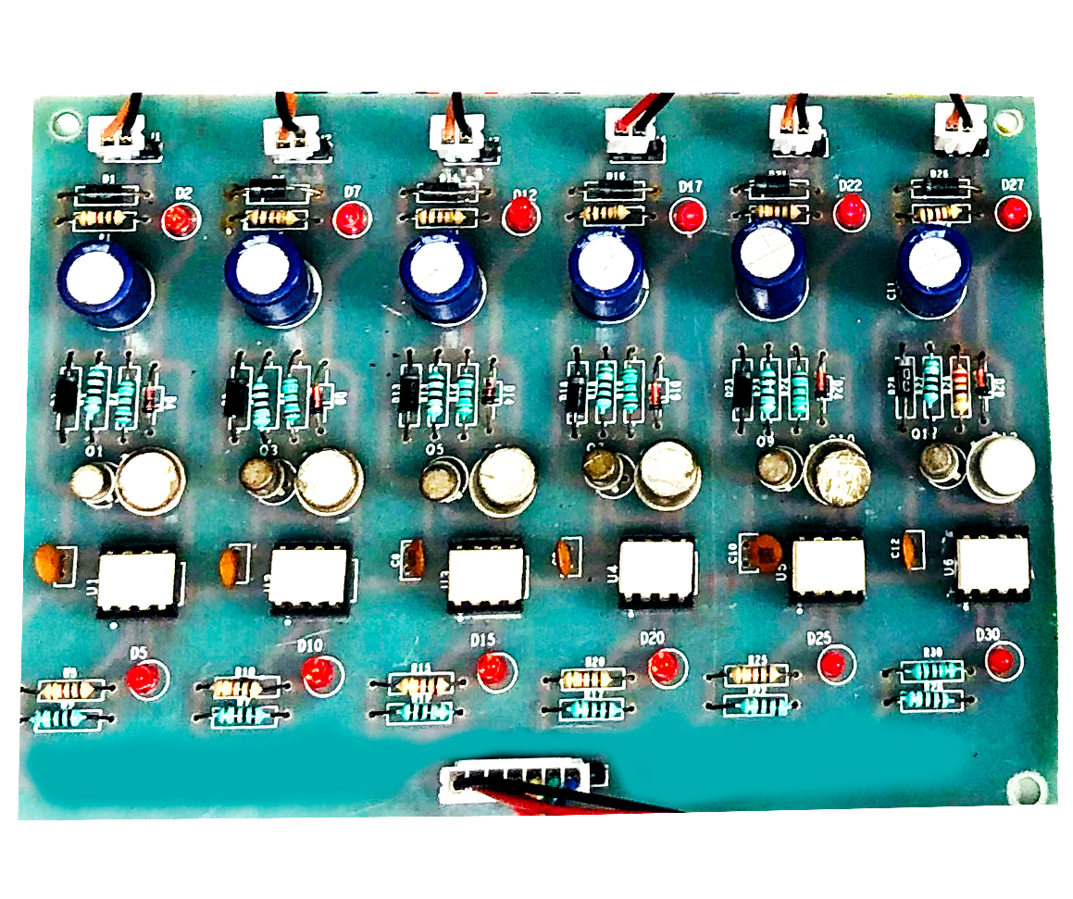
Dspic Controller Board
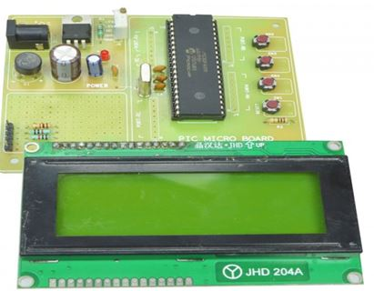
Working
The DSPIC controller is used to generate the PWM pulses for converter and inverter circuit. The DSPIC controller pulses are given to the driver circuit as input. Driver board is mainly used to isolate and amplify the input signals from the controller. The amplified driver output is connected to the main power circuit devices. The duty cycle applied to the SEPIC converter to vary the output voltage. Three phase inverter PWM is generated based on Hall sensor feedback.
Circuit Diagram For Sepic Converter
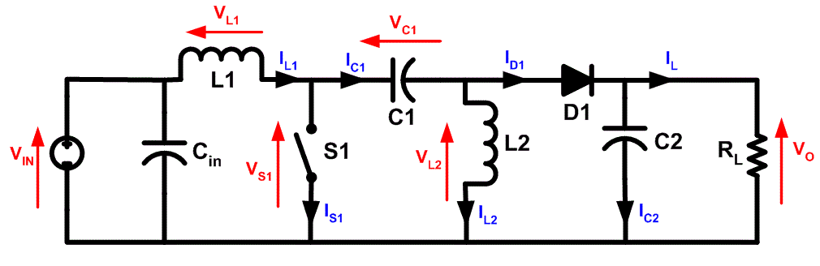
Circuit Diagram For Three Phase Inverter

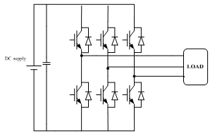
Advantages
- Easy to control speed
- Highly reliable
- High efficiency and lessmaintenance
- Less noise
Applications
- Industrial applications
- Water pumping system

Conclusion
This project is control the speed of the bldc motor by employing SEPIC converter and three phase inverter. This inverter has low switching losses and bldc motor control without any additional control. And also study the response of the all characteristics and theory. This project is highly reliable and obtains high efficiency of this control technique.
Output Waveform For Sepic Converter

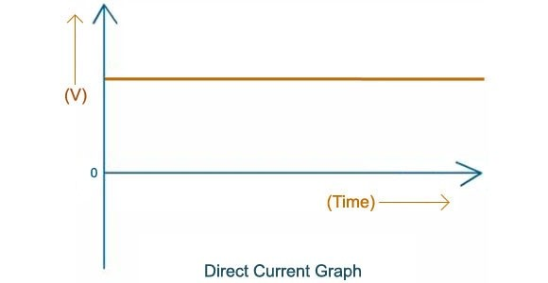
Bldc Motor Working Pattern

