**Speed Control of BLDC Motor**

**Abstract**

This project is mainly used to control the speed of the BLDC motor by varying the frequency. The BLDC motor has high reliability, high efficiency high torque/inertia ratio, improved cooling, low radio frequency interference, and noise and requires practically no maintenance. The BLDC motor speed is depends on the frequency of the three phase inverter circuit.

**Introduction**

The boost converter exhibits the advantages over the conventional buck, boost, buck–boost and Cuk converter when employed in SPV-based applications. The DC voltage is applied to three phase inverter circuit. Three phase inverter converts the dc voltage into three phase ac voltage. The boost converter operates to increase the output voltage.

**Proposed System**

This project is proposed to control the speed of BLDC motor. The AC supply is applied to the bridge rectifier, the bridge rectifier converts ac supply into dc supply. That dc supply is applied to three phase inverter; it converts the dc voltage into three phase ac voltage. Three phase ac voltage is connected to the BLDC motor. The BLDC motor have hall sensor. The hall sensor output is feedback to the controller. The three phase inverter Pulse depends on the hall sensor of BLDC motor. The DSPIC controller key functions are used to control the BLDC motor speed.

**Block Diagram**

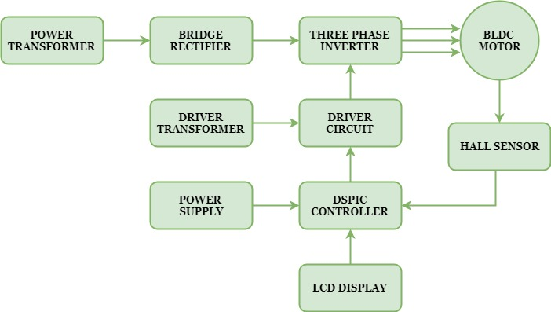

**Block Diagram Explanation**

* Pulse generator: - Here we have used DSPIC microcontroller (DSPIC 30F4011) to generate PWM signal.
* Driver circuit: -It is used to amplify the pulses and provided isolations using opto coupler. It has two functions,
* Amplification
* Isolation
* Bridge Rectifier: It converts AC supply to DC Supply.
* Three phase Inverter: It converts DC supply into three phase AC Supply to drive the BLDC motor.

**Driver Board**

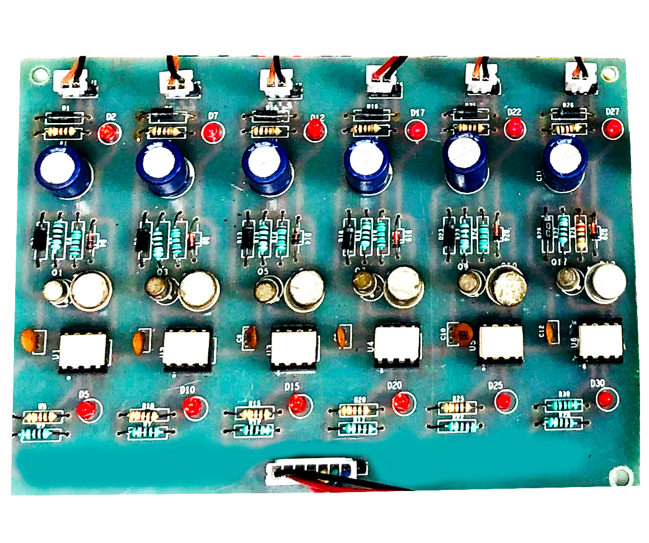

**DSPIC Controller Board**

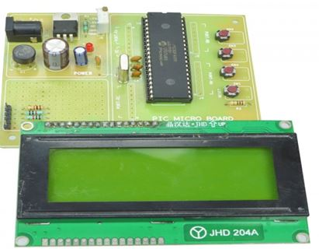

**Working**

The DSPIC controller is used to generate the PWM pulses for inverter circuit. The DSPIC controller pulses are given to the driver circuit as input. Driver board is mainly used to isolate and amplify the input signals from the controller. The amplified driver output is connected to the main power circuit devices. Three phase inverter PWM is generated based on Hall sensor feedback.

**Circuit Diagram for Three Phase Inverter**

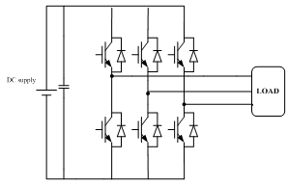

**Advantages**

* Easy to control speed
* Highly reliable
* High efficiency and less maintenance
* Less noise

**Applications**

* Industrial applications
* Water pumping system

**Conclusion**

This project is used to control the speed of the BLDC motor. This inverter has low switching losses and BLDC motor control without any additional control. And also study the response of the all characteristics and theory. This project is highly reliable and obtains high efficiency of this control technique.

**BLDC Motor Working Pattern**

