SPEED CONTROL OF THREE PHASE INDUCTION MOTOR BY EMPLOYING BOOST CONVERTER

ABSTRACT
This project is mainly used to control the speed of the three phase induction motor by employing boost converter. The Boost converter is used to step up the input dc voltage. The boost converter output voltage depends on the duty cycle of the converter. The three phase induction motor has high reliability, high efficiency high torque/inertia ratio, improved cooling, low radio frequency interference, and noise and requires practically no maintenance.

INTRODUCTION
The boost converter exhibits the advantages over the conventional buck, boost, buck–boost and Cuk converter when employed in SPV-based applications. The boost converter dc voltage is applied to three phase inverter circuit. Three phase inverter converts the dc voltage into three phase ac voltage. The boost converter operates to increase the output voltage.

PROPOSED SYSTEM
This project is proposed to control the speed of three phase induction motor by employing boost converter. The AC supply is applied to the bridge rectifier, the bridge rectifier converts ac supply into dc supply. That dc supply is applied to boost converter to boost the input voltage (i.e.) if input 15v dc means boost converter output voltage is greater than 15v dc voltage. That dc voltage is given to the three phase inverter; it converts the dc voltage into three phase ac voltage. Three phase ac voltage is connected to the three phase induction motor. The PIC controller key functions are used to control the three phase induction motor speed.

BLOCK DIAGRAM
BOOST
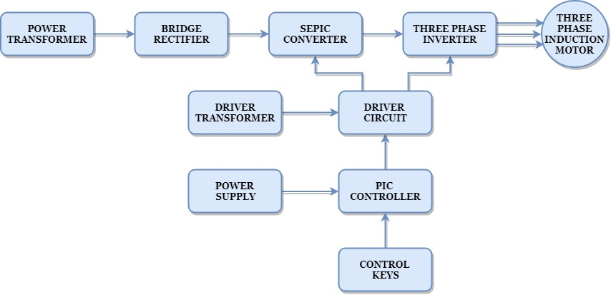

BLOCK DIAGRAM EXPLANATION
- Pulse generator: - Here we have used PIC microcontroller (PIC16F877A) to generate PWM signal.
- Driver circuit: -It is used to amplify the pulses and provided isolations using opto coupler. It has two functions,
- Amplification
- Isolation
- Bridge Rectifier: It converts AC supply to DC Supply.
- Boost converter: It converts low voltage DC to high voltage DC supply.
- Three phase Inverter: It converts DC supply into three phase AC Supply to drive the three phase induction motor.
DRIVER BOARD
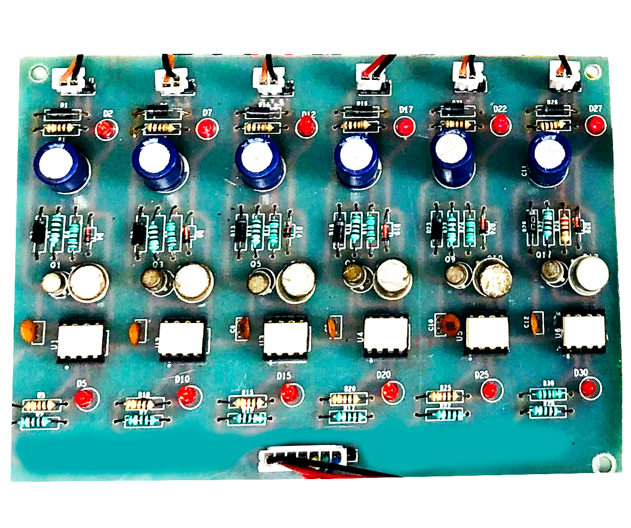
PIC CONTROLLER BOARD
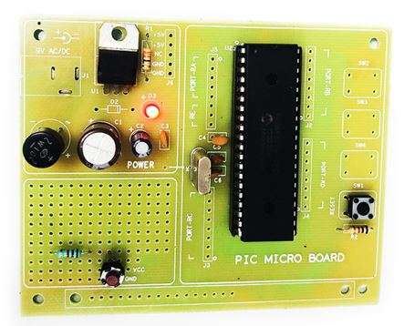
WORKING
The PIC controller is used to generate the PWM pulses for converter and inverter circuit. The PIC controller pulses are given to the driver circuit as input. Driver board is mainly used to isolate and amplify the input signals from the controller. The amplified driver output is connected to the main power circuit devices. The ac supply is converted into dc by using bridge rectifier. And the dc voltage is boosted by using boost converter. The boosted dc voltage is applied to inverter circuit and by varying the frequency of the inverter the motor speed also varied.
CIRCUIT DIAGRAM FOR BOOST CONVERTER
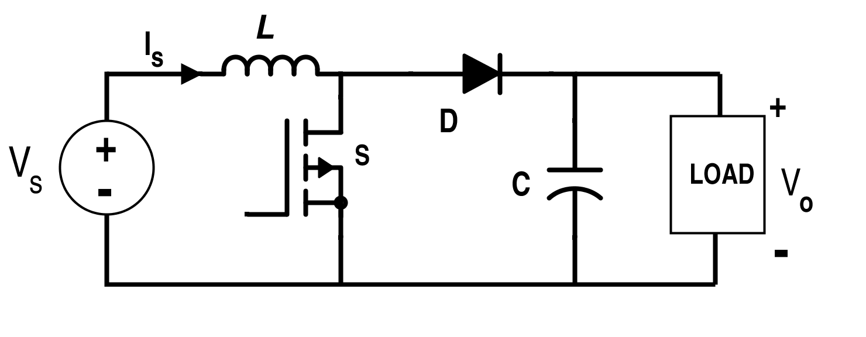
CIRCUIT DIAGRAM FOR THREE PHASE INVERTER
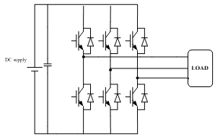
ADVANTAGES
- Easy to control speed
- Highly reliable
- High efficiency and less maintenance
- Less noise
APPLICATIONS
- Industrial applications
- Water pumping system
CONCLUSION
This project is control the speed of the three phase induction motor by employing boost converter and three phase inverter. This inverter has low switching losses and three phase induction motor control without any additional control. And also study the response of the all characteristics and theory. This project is highly reliable and obtains high efficiency of this control technique.
OUTPUT WAVEFORM FOR BOOST CONVERTER

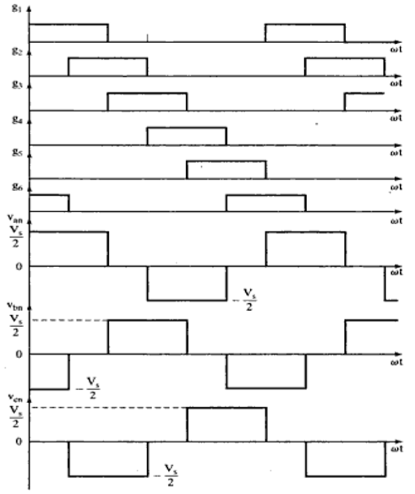
THREE PHASE INVERTER PATTERN

