Speed Control of Single Phase Induction Motor Using Node MCU

Abstract
This project is used to control the speed of single phase induction motor by using Node MCU controller. The single phase inverter converts dc voltage into ac voltage. Single phase induction motor speed depends on the frequency of inverter.

Details for 3 Phase Inverter Board

The inverter card comes with inbuilt full bridge rectifier and filter capacitor. 4 No’s of IRFP250 MOSFET’s are mounted with Heat sink. The output of the inverter is terminated with 2 pin PTB Connector. The user should get soldered on back side of the board for gate pulse interface.
➣4 No’s of IRFP250 MOSFET are mounted with proper Heat sink
➣5A Bridge Rectifier with DC Filter Capacitor (1000uF/250V)
➣2 Pin PTB Connector provided to connect Motor

INVERTER SCHEMATIC DIAGRAM
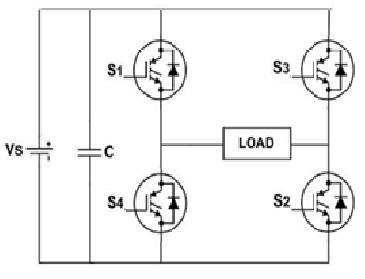
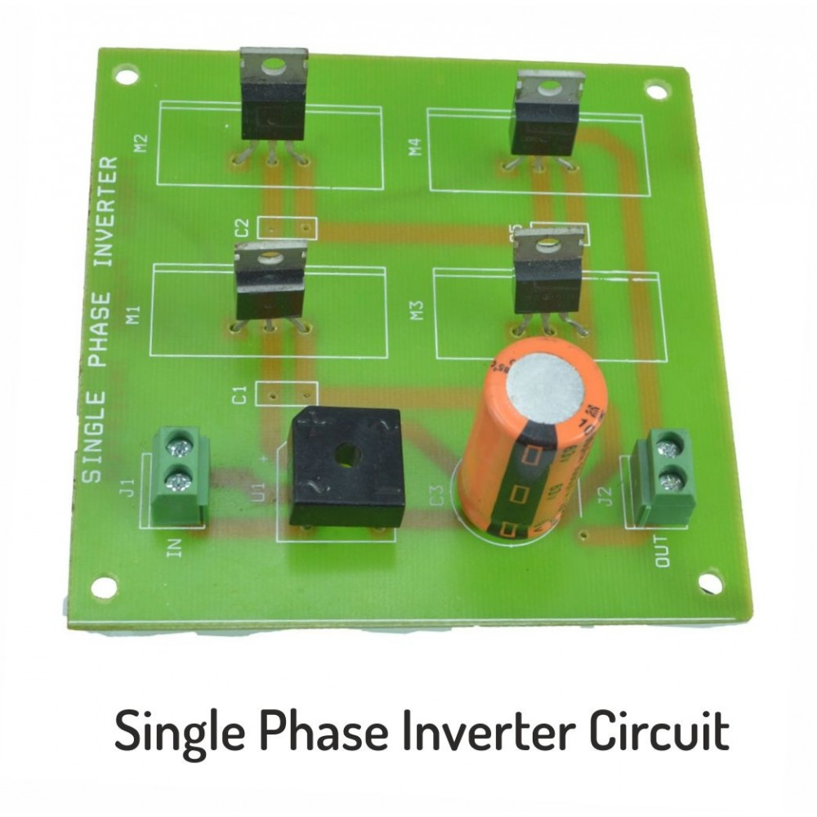

Specification

➣4 No’s of IRFP250 MOSFET with Heat sink
➣Input Voltage 100V/AC/50Hz
➣Operating Frequency 25 KHz
➣Input and Outputs are terminated with PTB Connectors

TLP 250 DRIVER BOARD

Specification
➣4 No’s Opto-Isolated Gate Drive
➣Input Voltage 12V/AC/50Hz
➣Operating Frequency 25 KHz
➣All input and outputs are terminated with RMC Male Connectors

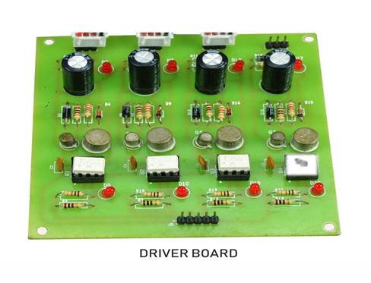

Block Diagram

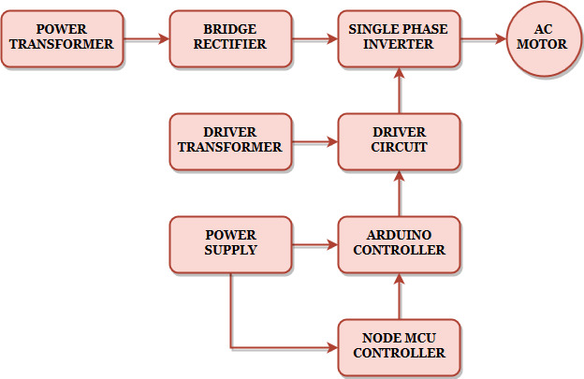

Block Diagram Explanation
- Pulse generator: - Here we have used PIC microcontroller (PIC 16F877a) to generate PWM signal.
- Driver circuit: It is used to amplify the pulses and provided isolations using opto coupler. It has two functions,
- Amplification
- Isolation
- Bridge Rectifier: It converts AC supply to DC Supply.
- Single phase Inverter: It converts DC supply to single phase AC Supply to drive the single phase induction motor.

Node MCU Controller

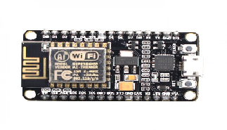

Working
The Node MCU controller is used to generate the PWM pulses for inverter circuit. The Node MCU controller pulses are given to the driver circuit as input. Driver board is mainly used to isolate and amplify the input signals from the controller. The amplified driver output is connected to the main power circuit devices. The ac supply is converted into dc by using bridge rectifier. And the dc voltage is applied to inverter circuit and by varying the frequency of the inverter the motor speed also varied.
Advantages
- High efficiency
- Easy to control the speed
- Switching losses are reduced
Applications
- Industrial applications
- Pumping system
Conclusion
The speed control of single phase induction motor by using Node MCU controller. The PWM pulses are generated by using Node MCU controller. The single phase inverter frequency is varied by using increment and decrement switches. The single phase inverter output waveform is shown in below.

Inverter Output Waveform

