Raspberry Pi based voice assistance using Android app

Introduction
A virtual assistant is a well-known application, which includes all functionalities like cloud, IoT and some assisting actions. This project helps you to begin with virtual assistance using android mobile which is interfaced with the Raspberry Pi. Android mobile is used only for mic interface so that you can give the voice commands through the Android mobile to the raspberry pi via Bluetooth.

Abstract
This project uses Raspberry Pi as the core, which is connected with the Internet. Voice command is given from the Android mobile by installing the android application in mobile. Mobile is connected with the Raspberry Pi via Bluetooth. This commands are received in Raspberry Pi and processed based on applications. It includes cloud-based applications like Weather report and also it has more feature like capturing the image while saying cheese, entertainment like talking tom, IoT commands like ping the Mail, Taking short line notes which convert voice to text and save it in log file and Date and time requests also can be done.

Existing system
Inthe existing system, voice-controlled robotic car or robotic arm is done using android mobile.

Proposed system
In this proposed system, more functionalities like image application, cloud function, Iot, and every feature emerge in this project.

Block diagram

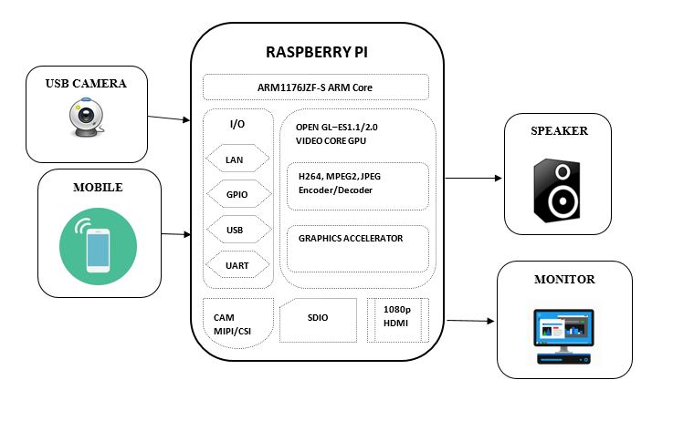

Block diagram description
- Speaker is connected to the 3.5 mm audio jack of the Raspberry Pi
- The monitor is connected with HDMI port of Raspberry Pi
- Android mobile is connected with the Raspberry Pi via Bluetooth
- USB Camera is interfaced with the Raspberry Pi

Project description
Since this is the personal virtual assistance, Face recognition is also added, the assistant will work only if the Face gets authenticated and after recognized it will wait for the voice command. Based on certain function received, applications can be performed. Face recognition works by using Haar cascade frontal face algorithm to recognize the Face. The system always looking for the face, if it matches its ready to assist the person. Voice command is given from the Android mobile based on command applications are performed automatically.

Hardware required
- Raspberry Pi
- Speaker
- USB camera

Software required
- Raspbian Jessie
- Python
- “Pi3 Bluetooth manager” android app

Results
A prototype of virtual assistance is done using Face recognition, cloud processing for a weather report, IoT. This can be modified or further innovated in many ways by using “Re speaker” for a mic instead of using android mobile with chatbot applications using machine learning.

