Novel Seven Level Dc to Ac Inverter Using PIC Controller

Abstract

This project is based on cascaded H bridge inverter and various topologies. Inverters are mainly used for commercial and industrial purposes. The multilevel inverter is low harmonics in output voltage. As the number of level increases the harmonic content of output voltage waveform decreases. The switching losses and the voltage stress of power devices can be reduced and also the low pass filter is used for reduce the harmonics.

Introduction

Multilevel inverter provides a suitable solution for medium and high power systems to synthesize an output voltage which allows a reduction of harmonic content in voltage and current waveforms. The solar photovoltaic (PV) modules directly converts the light energy into the electrical energy, but energy obtained from the PV module acts as low voltage DC source and has relatively low conversion efficiency.

Existing System

This seven level inverter has 8 power switches. In normal cascaded multilevel inverter is not suitable for high voltage applications. For this converter is used for high voltage applications. In normal inverter has conduction loss and switching losses. This converter is overcome the drawbacks of previous seven level inverter.

Proposed System

The novel seven level inverter has 3 capacitors (c1, c2, c3) and 8 power switches. This project has One H Bridge inverter for converts the dc voltage into ac voltage. The three input capacitors are divided the input voltages. The gate pulses are generated by using the pic microcontroller. If the pulses of the inverter are varied the output is not produced properly. The input voltage is applied by using three different sources or voltage divider by using capacitor.
Block Diagram

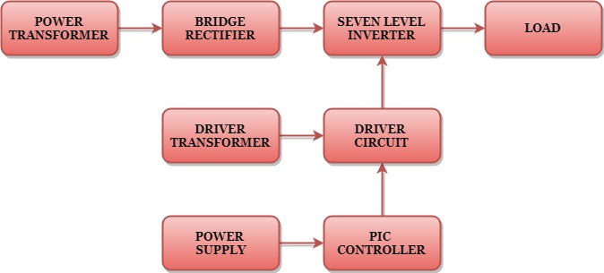

Block Diagram Explanation

- Pulse generator: - Here we have used PIC microcontroller (PIC 16F877A) to make a switching signal.
- Driver circuit: -It can be used to amplify the pulses and provided isolations by using opto coupler. It has two functions,
- Amplification
- Isolation

- Bridge Rectifier: It converts AC to DC Supply.
- Inverter: It converts DC voltage to step AC voltage.

Driver Board
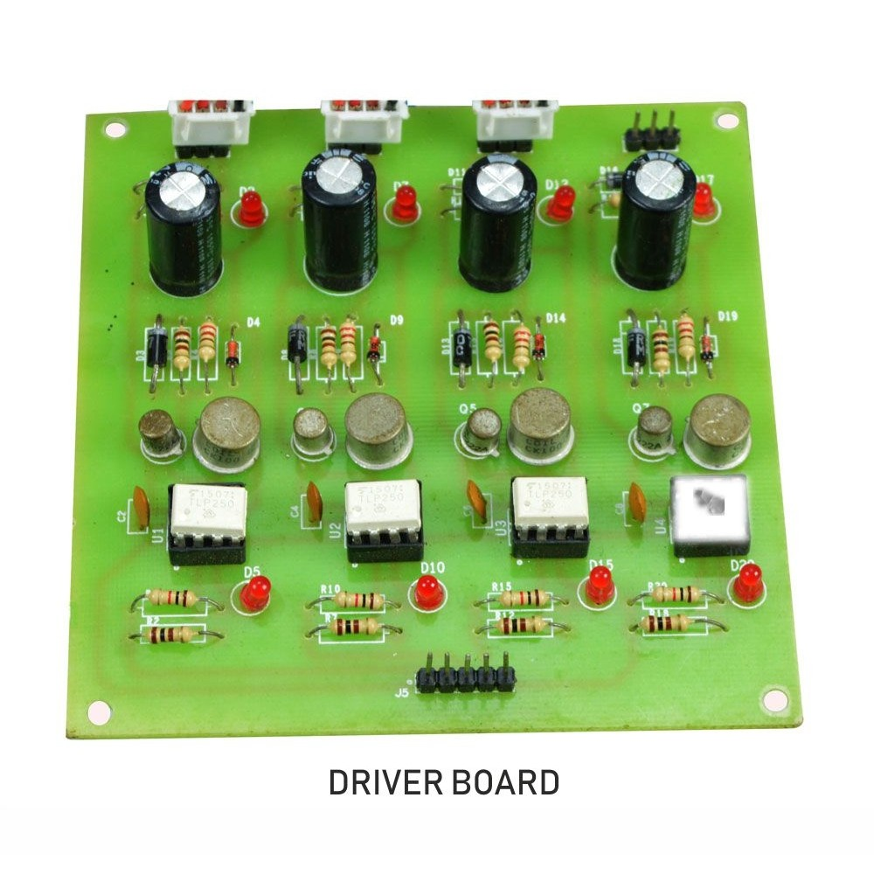

PIC Controller Board

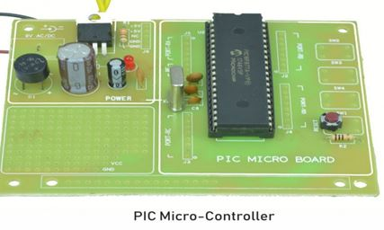

Working
The pic controller is used to generate the PWM pulses for converter and inverter circuit. The pic controller pulses are given to the driver circuit as input. Driver board is mainly used to isolate and amplify the input signals from the controller. The amplified driver output will be connected to the main power circuit devices. And the devices are turned on by using the PWM pulses. The power transformer is directly connected to the bridge rectifier. The bridge rectifier converts the ac voltage into dc voltage. Dc voltage is converted into ac voltage by using novel multilevel inverter circuit. The multilevel inverter output waveform is shown in below.
Circuit Diagram For Dc To Ac Inverter

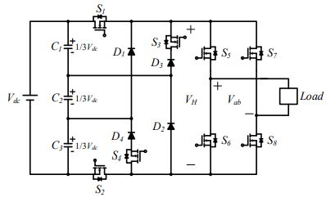
Advantages
- Reduce the switching loss.
- High efficiency.
- Reduced THD.
Applications
- Industrial machines
- High Power Applications
Conclusion
In this project it reduces the uneven degradation of power switches, switching losses when compared to the conventional PWM technique and harmonics are reduced and the output waveform level is increased. And also increase the efficiency. The number steps is increased means reduce the harmonics of the inverter.

Multilevel Inverter Output

