New Five-Level Active Neutral Point Clamped Converter

Abstract

This project is based on cascaded H bridge inverter and various topologies. Inverters are mainly used for commercial and industrial purposes. The multilevel inverter is low harmonics in output voltage. As the number of level increases the harmonic content of output voltage waveform decreases. The five level active neutral point clamped (5L-ANPC) converter is most advantageous topologies. This 5L-ANPC converter is overcome the previously employed 5L-ANPC.

Introduction

Multilevel inverter provides a suitable solution for medium and high power systems to synthesize an output voltage which allows a reduction of harmonic content in voltage and current waveforms. The solar photovoltaic (PV) modules directly converts the light energy into the electrical energy, but energy obtained from the PV module acts as low voltage DC source and has relatively low conversion efficiency.

Existing System

This five level inverter has 12 power switches. In normal cascaded multilevel inverter is not suitable for high voltage applications. For this converter is used for high voltage applications. In normal inverter has conduction loss and switching losses. This converter is overcome the drawbacks of previous five level inverter.

Proposed System

The C1 flying capacitor of the new topology is dimensioned like the C1 capacitor of the previously employed 5L-ANPC. C2 and C3 capacitors are much smaller comparing to C1, their size is similar to the size of a decoupling capacitor and no control is required to maintain their voltages. The c2 and c3 are like as snubber circuit and reduce the over voltages during commutation period. The power devices are connected like series connection to block the voltage.
Block Diagram
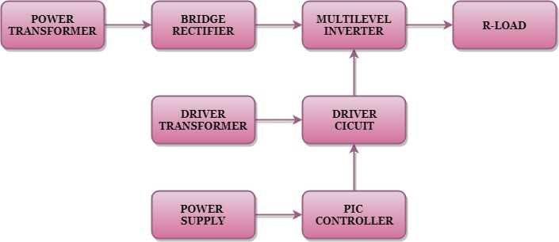

Block Diagram Explanation

- Pulse generator: - Here we have used PIC microcontroller (PIC 16F877A) to make a switching signal.
- Driver circuit: -It can be used to amplify the pulses and provided isolations by using opto coupler. It has two functions,
- Amplification
- Isolation
- Bridge Rectifier: It converts AC to DC Supply.
- Inverter: It converts DC voltage to step AC voltage.
The new five level active neutral point clamped converter output is shown in the below.

Driver Board
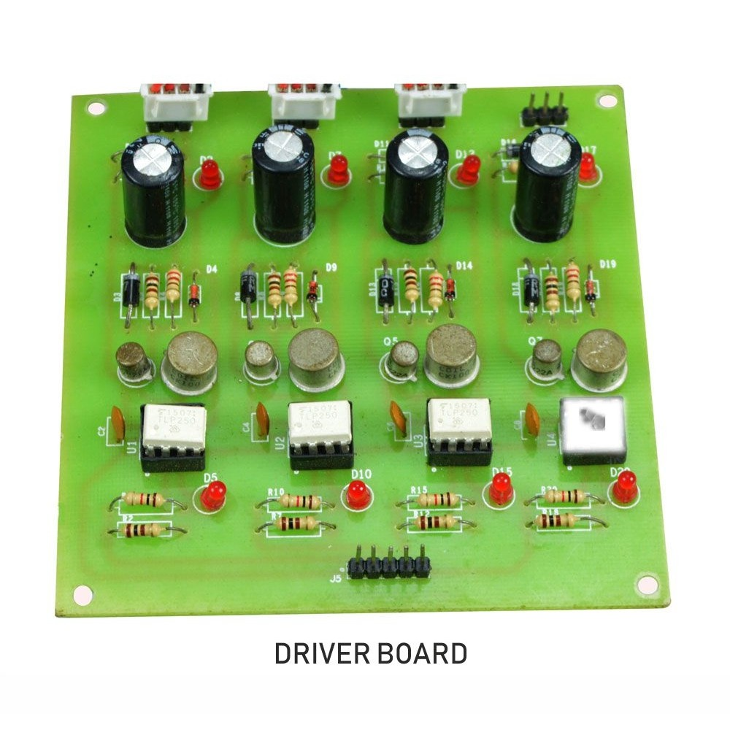

PIC Controller Board

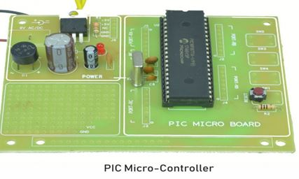

Working
The PIC controller is used to generate the PWM pulses for converter and inverter circuit. The PIC controller pulses are given to the driver circuit as input. Driver board is mainly used to isolate and amplify the input signals from the controller. The amplified driver output will be connected to the main power circuit devices. And the devices are turned on by using the PWM pulses. The power transformer is directly connected to the bridge rectifier. The bridge rectifier converts the ac voltage into dc voltage. Dc voltage is converted into ac voltage by using multilevel inverter circuit. The multilevel inverter output waveform is shown in below.
Circuit Diagram for Dc to Ac Inverter
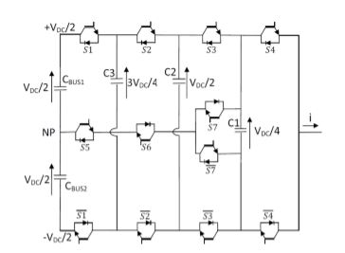
Advantages
- Reduce the switching loss.
- High efficiency.
- Reduced THD.
Applications
- Industrial machines
- High Power Applications
Conclusion
In this project it reduces the uneven degradation of power switches, switching losses when compared to the conventional PWM technique and harmonics are reduced and the output waveform level is increased. And also increase the efficiency.

Multilevel Inverter Output

