HIGH GAIN FLYBACK CONVERTER

Abstract
This project is used to maximize the power level, which can reduce current ripple, reduce the size of the passive component and reduce the overall cost. This project is used for three stage flyback converter. This converter works in discontinuous current mode (DCM), it provides the fast dynamic response, easy control, no reverse recovery losses and no turn ON losses. Three stage flyback converter used to produced high voltage.

Introduction
Three stage flyback converter developed for high power application by interleaving single stage as central-type PV inverter. It has many advantages such as, 1) frequency of undesired harmonics gets increased at waveform in proportion to the number of interleaved stages. 2) Facilitate easy filtering of undesired harmonics using smaller sized filter. 3) Reduced size of capacitor and inductors. It helps in designing compact size of inverter.
Existing System
The conventional flyback inverter is used for low power applications. For high power application air gap of transformer is needs to increase. As increase in air gap of transformer, unfortunately magnetizing inductance size gets reduced but the leakage inductances are increased. Such leakage inductance cause high voltage spikes on the MOSFET switches leads to poor efficiency, large leakage flux and poor coupling. Due to such disadvantages the conventional flyback converter are not designed for the high power application. Conventional flyback converter limited role in PV application and produces low power, can only employed for micro inverter.

Proposed System
The flyback converter dc output will be connect to the full bridge inverter circuit.The main function of magnetizing inductance is to store the magnetic field energy. During turn-on period of switches they can’t flow through the secondary side due to the current blocked by the reversed biased diode.During turn-off period of switches, the magnetic field store energy of the magnetizing inductance is delivered to the grid in the form of current. So, the operation of the above configuration based on the flyback inverter and behaves as a voltage controlled current source.
Block Diagram
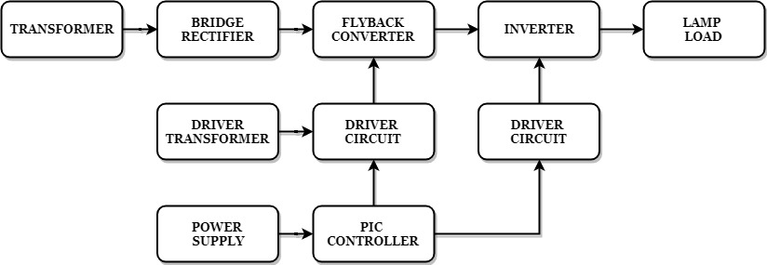
Block Diagram Explanation
- Pulse generator: - Here we have used PIC microcontroller (PIC 16F877A) to make a switching signal.
- Driver circuit: -It can be used to amplify the pulses and provided isolations using opto coupler. It has two functions,
      - Amplification
      - Isolation
- Converter: It is used to convert DC to DC Supply.
- Inverter: It is converted into DC to AC supply.
Driver Board
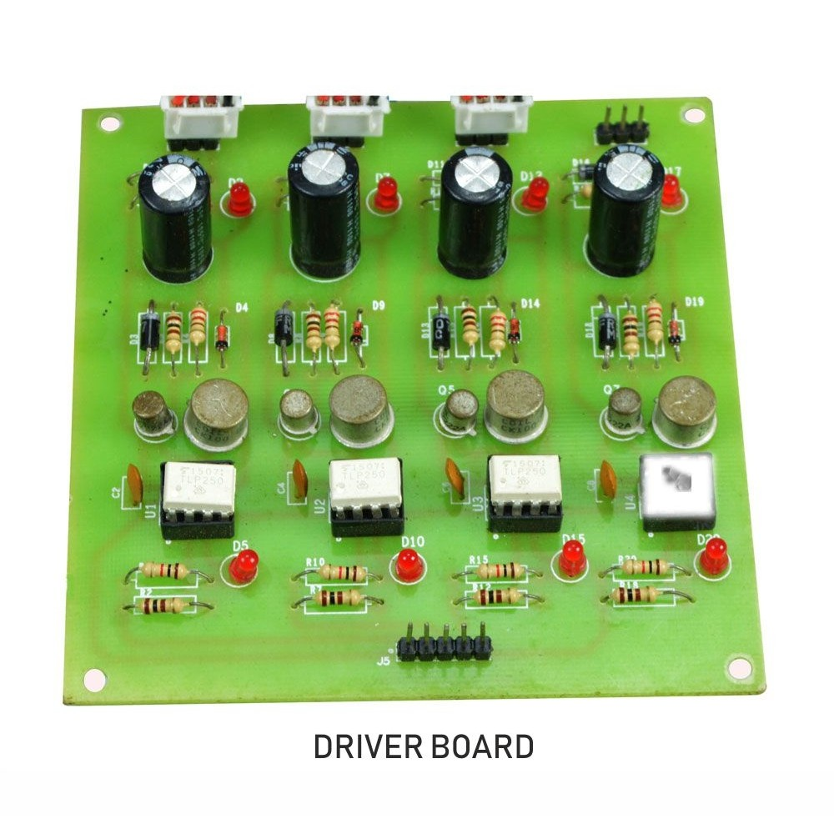
Pic Controller Board
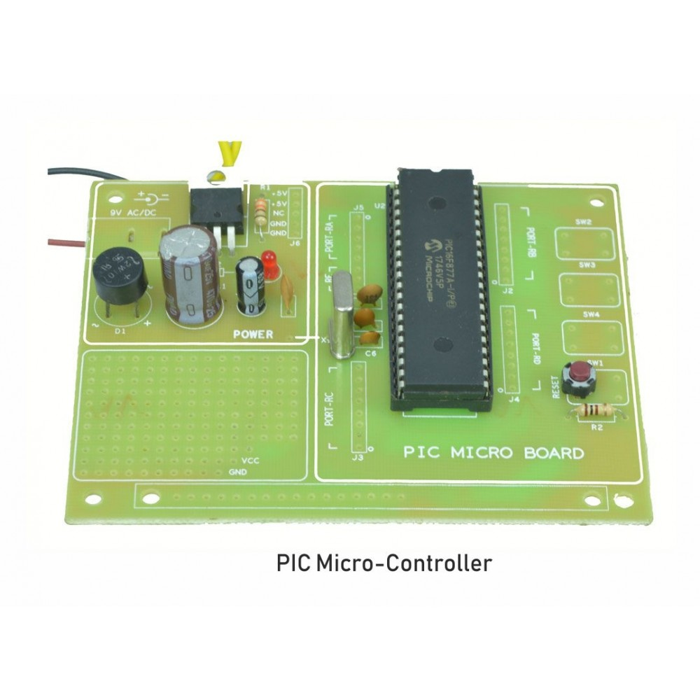
Working
The pic controller is used to generate the pwm pulses for converter and inverter circuit. The pic controller pulses are given to the driver circuit as input pulse. Driver board is mainly used to isolate and amplify the input signals of controller. The driver circuit amplified output will be connected to the main power circuit devices. The power transformer ac supply is connected to bridge rectifier. So,ac supply is converted to dc. This dc is applied to flyback converter and this dc voltage is stepped up. That stepup dc voltage is applied to full bridge inverter. Dc voltage is converted into ac voltage and connected to lamp load.

Circuit Diagram For Flyback Converter
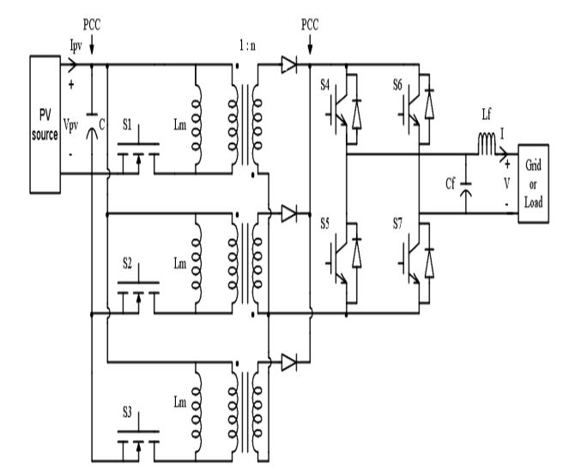

Advantages
- High gain
- High efficiency
- Easy power flow

Applications
- High power applications
- PV applications
Conclusion
The flyback topology is introduced effectively with interleaving the 3-flyback cells. This flyback converter operated with the discontinuous current mode (DCM). The central-type photovoltaic inverter is based on the flyback topology it gives the effective output for photovoltaic application. The flyback DC-DC converter topology is preferred because of its simplicity in design and easy power flow control with at high power quality output at the grid integrate.

Inverter Output Waveform:
