Boost Converter Using Arduino

Abstract
In most of PV application boost converter is used for boost the input voltage. The solar panel voltage is small, so the output voltage of the solar panel is applied to the converter and increases the input voltage by using this converter. The duty cycle of the converter is varied by Arduino controller. The duty cycle is varies, the output voltage of the converter also varied.
Introduction
The boost converter is a DC to DC converter. The dc to dc converter is input voltage is converts into another level of output voltage. An example boost converter input voltage is 12v and the output voltage is greater than 12v. They play an important role in renewable energy sources such as solar energy, hybrid vehiclesystems, etc. Boost converter is a class ofswitched mode power supply. It consists of at least two semiconductor switches and at least one energy storage element such as capacitor or inductor or the combination of the both.
Proposed System
The Boost Converter input voltageis boosted or increased and highvoltage appears at the output. A boostconverter or step upvoltage regulator provides non isolated, switch mode dc – dcconversion with the advantage of simplicity and low cost. Dc-dc boostconverter that accepts a dc input and pulse widthmodulation of switching frequency to control the output voltage. The input dc voltage is applied to inductor and inductor stores the energy. When switch is closed the stored energy is supply to capacitor and capacitor is charged. And switch is opens the capacitor voltage is discharged to resistive load. The boost converter output voltage is shown in the below.

Block Diagram For Boost Converter Using Arduino
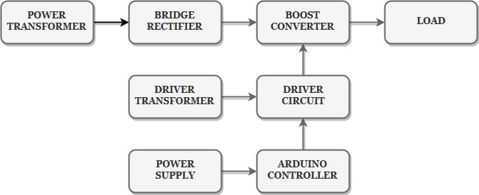

Block Diagram Explanation
- Pulse generator: - Here we have used Arduino Uno controller to generate PWM signal.
- Driver circuit: It is used to amplify the pulses and provided isolations using opto coupler. It has two functions,
- Amplification
- Isolation
- Bridge Rectifier: It converts AC supply into DC Supply.
- Boostconverter: It converts low voltage DC into high voltage DC supply.

Driver Board
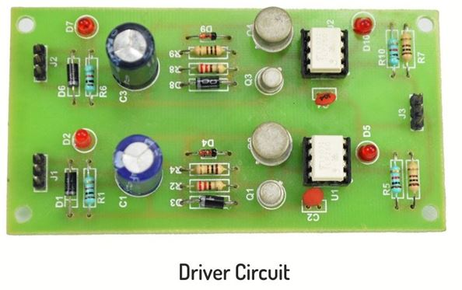
Arduino Controller

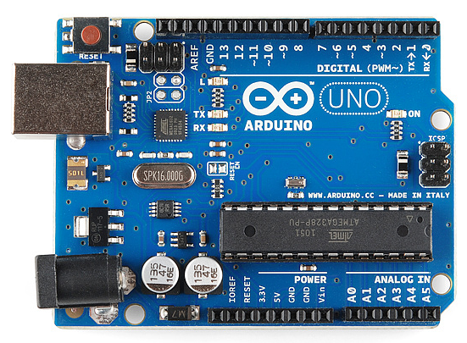

Working
The Arduino controller is used to generate the PWM pulses for converter and converter circuit. The Arduino controller pulses are given to the driver circuit as input.Driver board is mainly used to isolate and amplify the input signals from thecontroller. The amplified driver output is connected to the main power circuitdevices. The ac supply is converts into dc by using bridge rectifier. And the dcvoltage is boosted by boost converter. That dc voltage is applied to resistive load andduty cycle of the converter is varying the output voltage also varied.
Circuit Diagram For Boost Converter
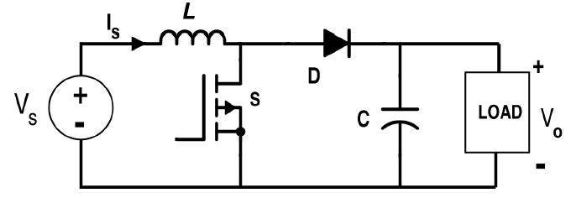
Advantages
- High efficiency
- Low cost
- Simple construction
Applications
- Dc to Dc converter
- PV applications
Conclusion
BoostConverter is an efficient stepup DC-DC converter used innumerous electronics devices. A closed loop model isdeveloped and used successfully. This converter has advantages like reduced components,high performance, less weight and accuracy. The converter output is depends on the duty cycle of the converter.
Output Waveform for Boost Converter

