Eye blink controlled virtual keyboard using Brainsense / Raspberry Pi

ABSTRACT
In our society there are more people suffered by paralytic diseases causes them several disabilities like they are unable to talk and unable to move physically and unable to express their everyday basic needs, but they can still use their eyes and sometimes move their heads. This Project is working under the principle of Brain-Computer Interface (BCI)
Our model helps them to type the letters using virtual keyboard, which is displayed in the monitor, designed using python programming. This system is having core system as Raspberry Pi. Virtual keyboard contains alphabets, numbers and some punctuations. Mouse pointer gets automatically shifted through every keys, characters can be chosen by making an eye blink at particular position of mouse pointer at certain character.
INTRODUCTION
The Brain-Computer Interface (BCI) is one of the communication channel used to make an interaction between the human brain and a digital computer. BCI which monitors EEG waves from the Brain. EEG –Electroencephalography which monitors an Electrical property of the Brain along with the Scalp (Non-invasive). The Neurosky Mindwave mobile / BrainSense measures intentionally directed EMG activity (blink strength). A brain-computer interface (BCI) is a new communication channel between the human brain and a digital computer. The ambitious goal of a BCI is finally the restoration of movements, communication and environmental control for handicapped people
The Raspberry Pi is a credit card sized single computer or SoC uses ARM1176JZF-S core. SoC, or System on a Chip, is a method of placing all necessary electronics for running a computer on a single chip. Raspberry Pi needs an Operating system to start up. In the aim of cost reduction, the Raspberry Pi omits any onboard non-volatile memory used to store the bootloaders, Linux Kernels and file systems as seen in more traditional embedded systems. Rather, an SD/MMC card slot is provided for this purpose. After boot load, as per the application program, Raspberry Pi will get executed.
EXISTING SYSTEM
In the existing system, every application is developed using Matlab, it requires a computer for processing signal and processing application through Matlab.
PROPOSED SYSTEM
Since the system uses Raspberry Pi, it does not require Matlab for processing the signal. Raspberry pi which has in built Bluetooth, so that there is no need of external Bluetooth. In this proposed system virtual keyboard is designed using python programming by having Tkinter library for virtual keyboard design and Pyautogui library for mouse pointer movement.

BLOCK DIAGRAM
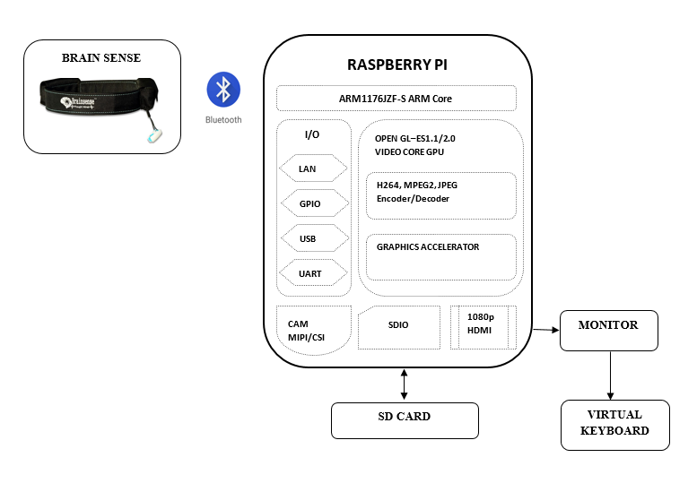

BLOCK DIAGRAM DESCRIPTION
Since, Raspberry Pi is small Pc, It is having option to connect monitor. Raspberry pi contains HDMI port; monitor can be connected by using VGA to HDMI convertor cable. BrainSense is connected with Raspberry pi using Bluetooth. Virtual keyboard, which is created using python programming, got displayed in the Monitor.

CIRCUIT DIAGRAM
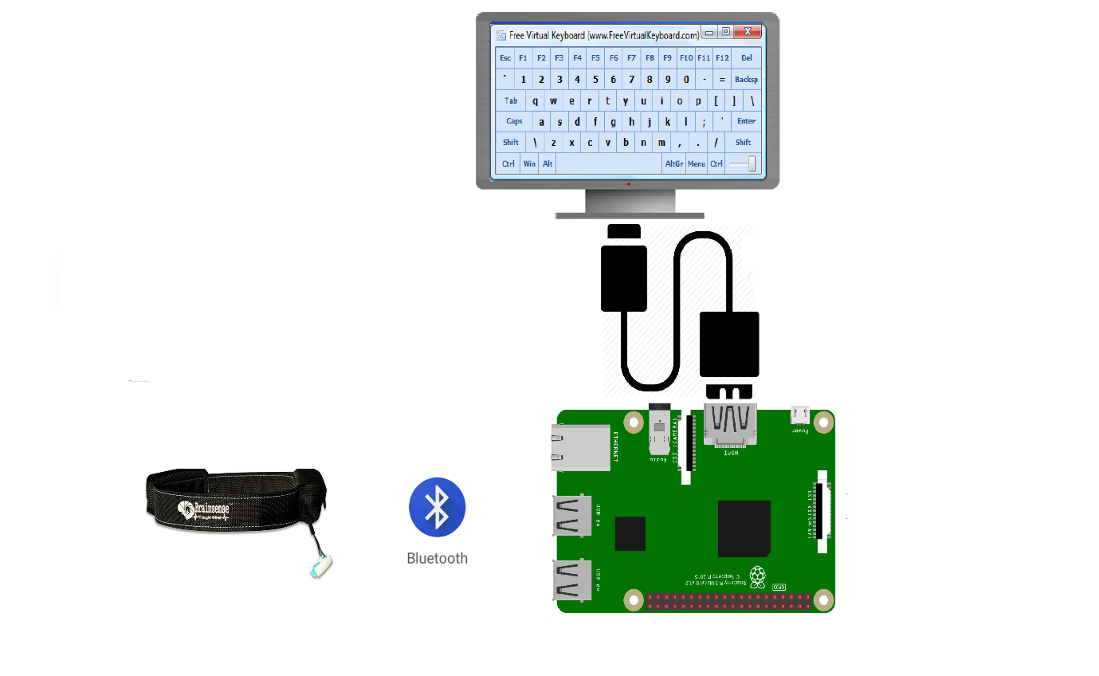
PROJECT DESCRIPTION
In this system, Raspberry Pi acts as a core, which these applications don’t require any laptop/pc with Matlab. Since it is mini Pc, it will process the signal by own. When the system begins to run, it opens the Virtual keyboard which contains alphabets, numbers and symbols. Then mouse pointer gets automatically move throughout every keys, whenever we make an eyeblink at certain keys, letter got selected and got typed. Before opening that virtual keyboard, we have to place cursor at notepad or anywhere that where we have to type the sentense. After that by making eyeblink at every position of mouse pointer, character got chosed and got typed.
HARDWARE REQUIRED
- Raspberry Pi
- Mindwave mobile or Brain sense
- Home automation kit (Appliances and Relay)

SOFTWARE REQUIRED
- Raspbian OS
- SD card Formatter
- Win32 disk imager
CONCLUSION
This system can be easily reconfigurable for further more keys. Further we can develop by including dictionaries with it, as well as we can develop this application with voice output. The intensity of Eyeblink differs for every human, we can reconfigure the code for high accuracy for blink detection.

