AUTOMATIC STREET LIGHT INTENSITY CONTROL USING HIGH BOOST DC TO DC CONVERTER

ABSTRACT
This project has a switched capacitor based dual switch high boost dc converter. This converter can obtain the high voltage gain in small duty cycle. This converter has an IR sensor for detecting the object. In normal condition, light has low intensity. If IR sensor is detecting, intensity of the light is increased. The light intensity is depending on the converter duty cycle.

INTRODUCTION
In most of the converters has coupled inductor for producing the high voltage. This converter is not used for the coupled inductors, so this converter has no leakage inductance and achieve high voltage gain and high efficiency. In this converter is used for reduce the energy consumption.
EXISTING SYSTEM
In other converter has the coupled inductor for producing the high voltage. For example, sepic converter and high gain fly back converter. This converter has also high voltage but switching losses and leakage inductance effects also presents. So, efficiency will be reduced.
PROPOSED SYSTEM
This converter has two switches for producing high voltages. When the switches, S1 and S2, were turned on, the input current was increased; further, when S1 and S2 were turned off, the input current was decreased. This converter has high voltage gain, high efficiency and low switching losses.
BLOCK DIAGRAM
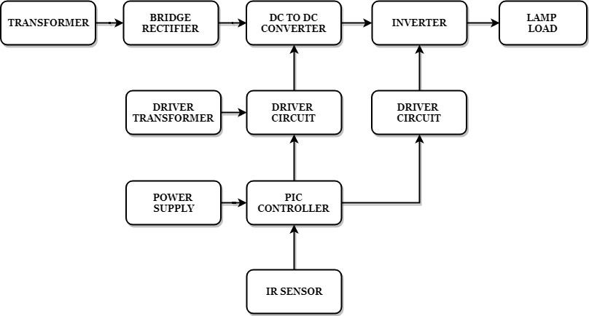

BLOCK DIAGRAM EXPLANATION
- Pulse generator: - Here we have used PIC microcontroller (PIC 16F877A) to make a switching signal.
- Driver circuit: -It can be used to amplify the pulses and provided isolations for using opto coupler. It has two functions,
- Amplification
- Isolation
- Converter: It is converted into DC to DC Supply.
- IR sensor: It detects the objects.

DRIVER BOARD
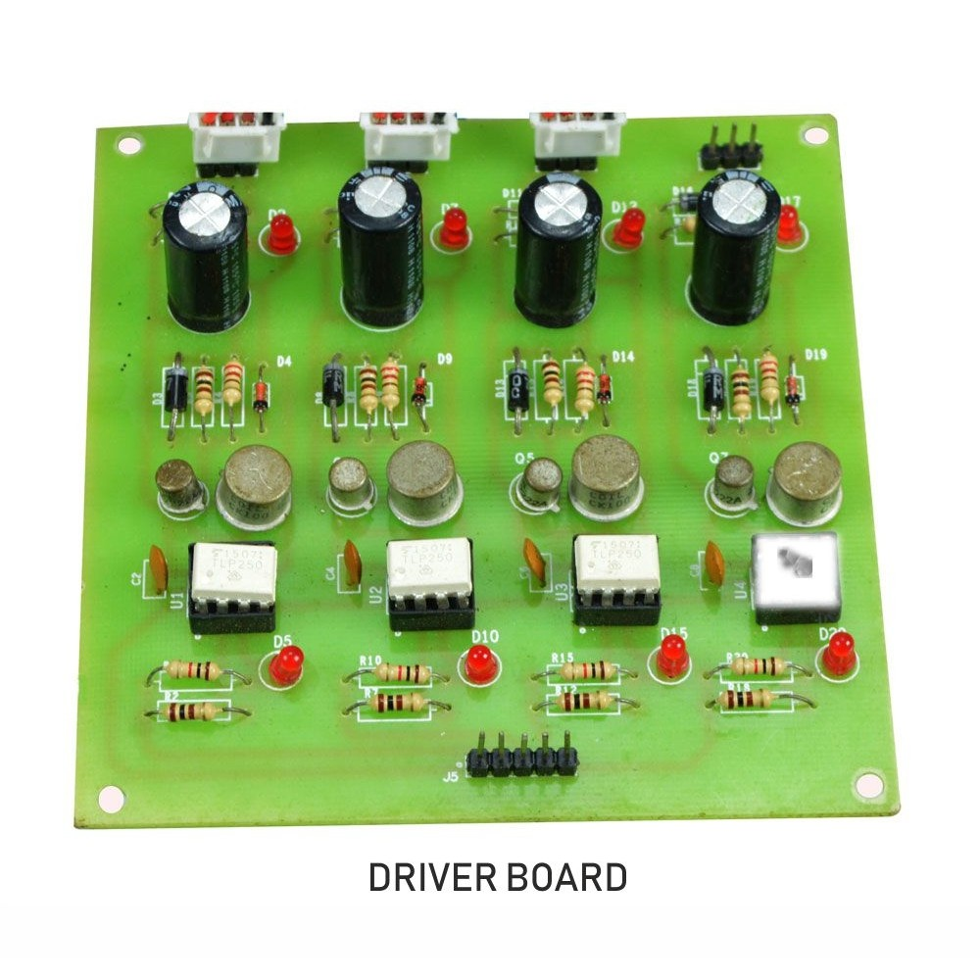
PIC CONTROLLER BOARD
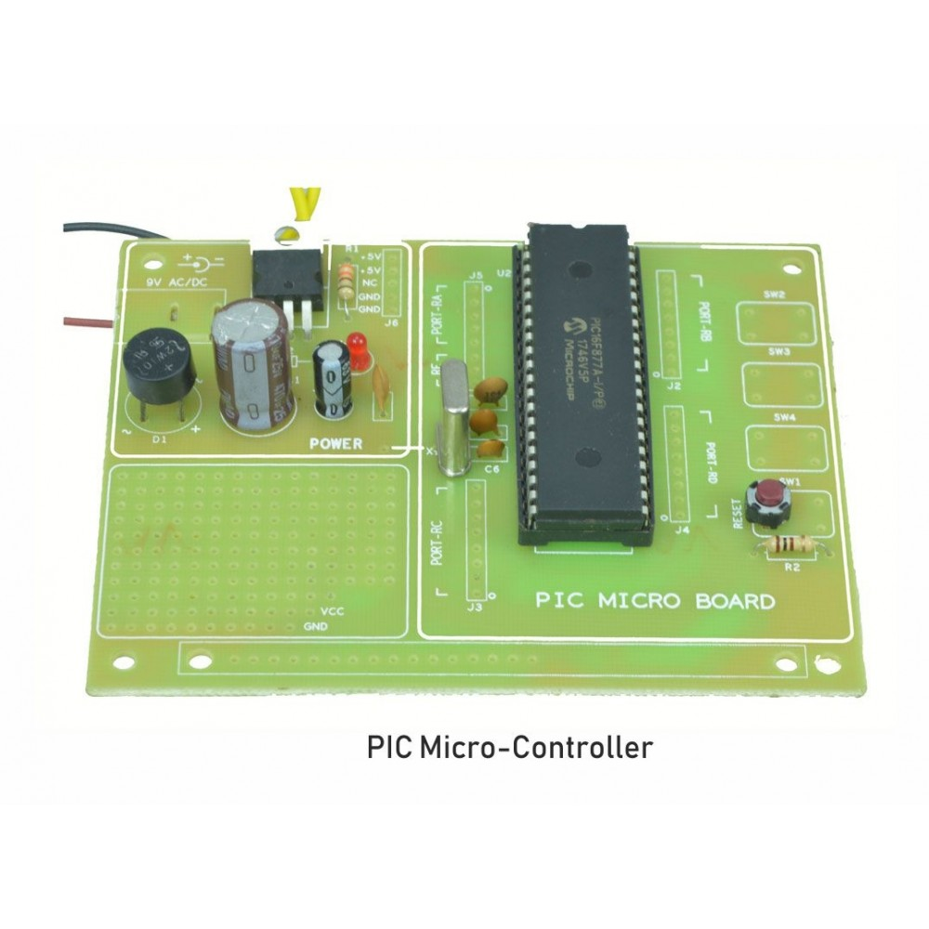
WORKING
The pic controller is used for generate the pwm pulses for converter and inverter circuit. The pic controller pulses are given to the driver circuit as input. Driver board is mainly used to isolate and amplify the input signals of controller pulses. The driver circuit amplified output will be connected to the main power circuit devices. The dc to dc converter converts the low dc voltage into high dc voltage. And inverter converts the dc voltage into ac voltage. In normal condition the lamp glow in low intensity. If IR detects any object the lamp will be glow in high intensity, it depends on the converter duty cycle.

CIRCUIT DIAGRAM FOR DC TO DC CONVERTER
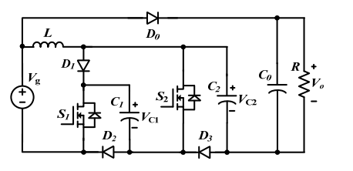

CIRCUIT DIAGRAM FOR INVERTER
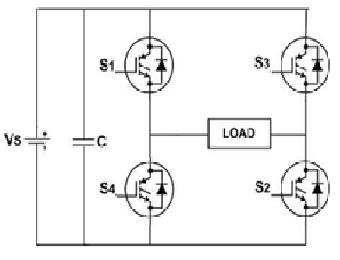
ADVANTAGES
- High step-up conversion
- High efficiency
- Increased gain value

APPLICATIONS
- Street light control
- Motor control
CONCLUSION
An SCDS(Switched Capacitor based Dual Switch) dc-dc converter has the features of the proposed SCDS converter are as follows: A simple structure, thereby achieving a high-voltage gain with a small duty cycle for the reduction of the conduction loss of the power switches, and a low-voltage stress on the MOSFETs and diodes. The operating principle, continous and discontinous conduction mode circuit analyses, and parameter design are presented. Also, an overall comparison between the proposed converter and other non-isolated dc-dc converters is addressed.
IN NORMAL CONDITION CONVERTER DUTYCYCLE
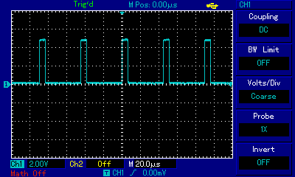
IR DETECTS OBJECT CONVERTER DUTYCYCLE
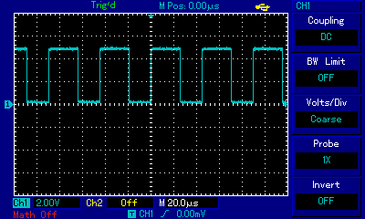
INVERTER OUTPUT
