TRANSFORMER BASED MULTILEVEL INVERTER TOPOLOGY WITH REDUCED COMPONENTS

ABSTRACT

This project is produce nine level output by using transformer topology. And also this inverter requiring only eight power switches only. It consist of two h bridges fed from single dc source. A single phase transformer is employed to aid the process of intermediate voltage level generation. And also reduce the voltage stress and total harmonic didtortion(THD).

INTRODUCTION

Multilevel inverter provides a suitable solution for medium and high power systems to synthesize an output voltage which allows a reduction of harmonic content in voltage and current waveforms. The solar photovoltaic (PV) modules directly converts the light energy into the electrical energy, but energy obtained from the PV module acts as low voltage DC source and has relatively low conversion efficiency. In order to improve the efficiency and convert low voltage DC source into usable AC source, the power electronics converters are used to transform DC into AC.

EXISTING SYSTEM

In normal cascaded inverters are used means increase the components counts and cost of multilevel inverter. The multilevel inverter is classified in 3 types they are cascaded MLI, flying capacitor MLI and transformer based MLI. The flying capacitor MLI inverter requires greater number of capacitors and also capacitor voltage balancing problem.

PROPOSED SYSTEM

This proposed multilevel inverter is used less number of power switches, so reduced the switching losses and total harmonics distortion(THD).And also easy to control the voltage of the multilevel inverter.

BLOCK DIAGRAM

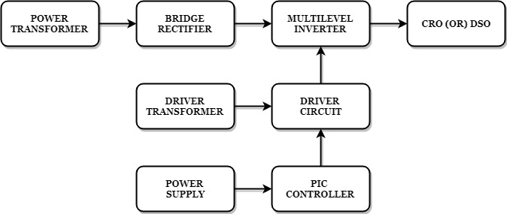

BLOCK DIAGRAM EXPLANATION
- Pulse generator: - Here we have used PIC microcontroller (PIC 16F877A) to make a switching signal.
- Driver circuit: -It can be used to amplify the pulses and provided isolations by using opto coupler. It has two functions,
- Amplification
- Isolation
- Bridge Rectifier: It converts AC to DC Supply.
- Inverter: It converts DC to AC Supply.

The nine level multilevel inverter by using transformer topology output waveform is shown in the below.

DRIVER BOARD
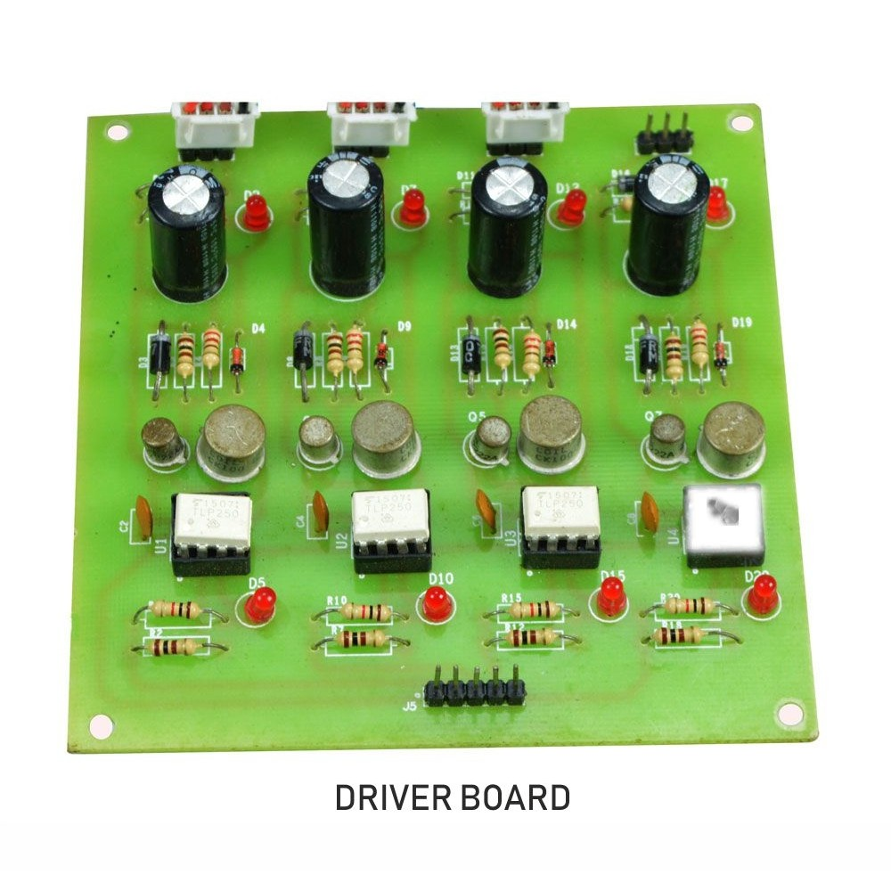

PIC CONTROLLER BOARD

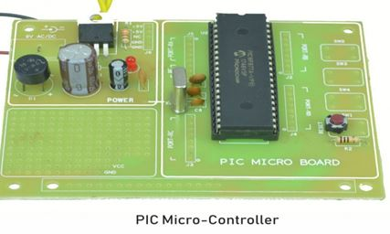

WORKING
The pic controller is used to generate the pwm pulses for converter and inverter circuit. The pic controller pulses are given to the driver circuit as input. Driver board is mainly used to isolate and amplify the input signals from the controller. The amplified driver output will be connected to the main power circuit devices. And the devices are turned on by using the pwm pulses. The power transformer is directly connected to the bridge rectifier. The bridge rectifier converts the ac voltage into dc voltage. Dc voltage is converted into ac voltage by using multilevel inverter circuit. The multilevel inverter output waveform is shown in below.
CIRCUIT DIAGRAM FOR NINE LEVEL INVERTER
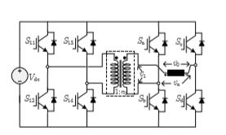
ADVANTAGES
- Reduce the switching loss.
- High efficiency.
- Reduced THD.
APPLICATIONS
- Industrial machines
- Automobiles medical equipment
- Household appliances
CONCLUSION
In this project it reduces the uneven degradation of power switches, switching losses when compared to the conventional PWM technique and harmonics are reduced and the output waveform level is increased. And also increase the efficiency.
MULTILEVEL INVERTER OUTPUT

