NINE LEVEL CASCADED MULTILEVEL INVERTER

ABSTRACT

This project is based on cascaded H bridge inverter and various topologies. Inverters are mainly used for commercial and industrial purposes. The multilevel inverter is low harmonics in output voltage. There are different types of multilevel inverters. As the number of level increases the harmonic content of output voltage waveform decreases. The nine level multilevel inverter will produce staircase output of the inverter.

INTRODUCTION

Multilevel inverter provides a suitable solution for medium and high power systems to synthesize an output voltage which allows a reduction of harmonic content in voltage and current waveforms. The solar photovoltaic (PV) modules directly converts the light energy into the electrical energy, but energy obtained from the PV module acts as low voltage DC source and has relatively low conversion efficiency. In order to improve the efficiency and convert low voltage DC source into usable AC source, the converters are used to transform DC into AC.

EXISTING SYSTEM

In normal nine level inverter wants 4 H-bridge inverters. For this nine level multilevel inverter needs 2 inverters only. So number of switches will be reduced, so switching losses will be reduced. In this nine level cascaded inverter is used for two single phase inverter circuits. The two inverters are connected in cascaded connections. This multilevel inverter circuit contains 8 power switches.

PROPOSED SYSTEM

This proposed multilevel inverter is used less number of power switches, so reduced the switching losses and total harmonics distortion(THD).And also easy to control the voltage of the multilevel inverter.

BLOCK DIAGRAM

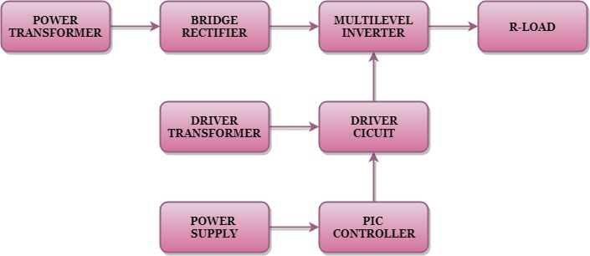

BLOCK DIAGRAM EXPLANATION
- Pulse generator: - Here we have used PIC microcontroller (PIC 16F877A) to make a switching signal.
- Driver circuit: -It is used to amplify the pulses and provided isolations by using opto coupler. It has two functions,
- Amplification
- Isolation
- Bridge Rectifier: It converts AC to DC Supply.
- Inverter: It converts DC to AC Supply.

The nine level multilevel inverter output waveform is shown in the below.
DRIVER BOARD
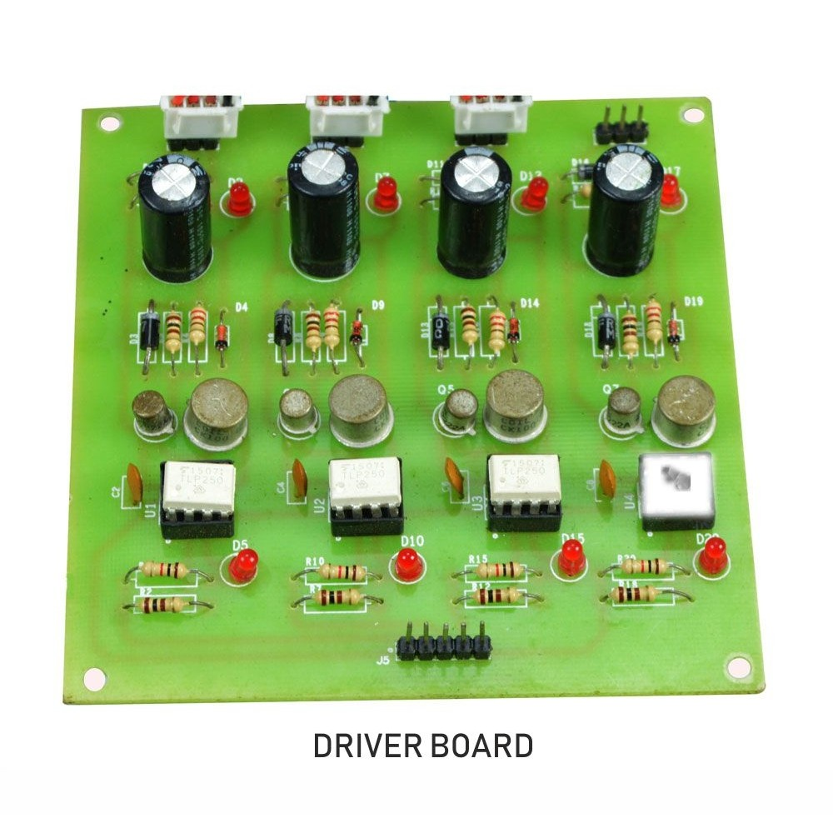

PIC CONTROLLER BOARD
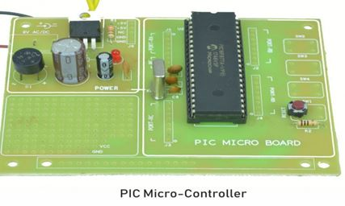

WORKING
The pic controller is used to generate the pwm pulses for inverter circuit. The pic controller pulses are given to the driver circuit as input. Driver board is mainly used to isolate and amplify the input signals from the controller. The amplified driver output will be connected to the main power circuit devices. And the devices are turned on by using the pwm pulses. The power transformer is directly connected to the bridge rectifier. The bridge rectifier converts the ac voltage into dc voltage. Dc voltage is converted into ac voltage by using multilevel inverter circuit. The multilevel inverter output waveform is shown in below. This inverter has two different potential sources (i.e. First inverter has 5V and Second inverter has 12V Sources)
CIRCUIT DIAGRAM FOR DC TO AC NINE LEVEL INVERTER
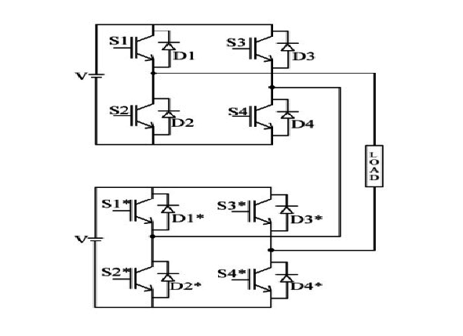ADVANTAGES
- Reduce the switching loss.
- High efficiency.
- Reduced THD.
APPLICATIONS
- Industrial machines
- Automobiles medical equipment
- Household appliances
- Airplanes
- High Power Applications
CONCLUSION
In this project it reduces the uneven degradation of power switches, switching losses when compared to the conventional PWM technique and harmonics are reduced and the output waveform level is increased. And also increase the efficiency.
MULTILEVEL INVERTER OUTPUT

