ABSTRACT
This paper presents the development of a smart sensor based environment monitoring system, in remote villages especially for crop fields. Basically, it is difficult to monitor the environment, weather all the time, so we proposed this project Crop field, to monitor the weather and any environment changes using IoT through SMTP and MQTT which having some sensors like Temperature sensor, Moisture sensor, Gas sensor and LDR which measures respective parameters throughout the day. At the same time sensors are not having ability to predict the weather accurately, so we are using weather cloud to know the current weather and climate change yet to happen, like every weather information is monitored, when there are any chances of rain in weather cloud then the camera gets triggered and capture the image of the atmosphere with the data log of current weather logs and upcoming weather logs are sent to mail by the user. And also parameters measured by sensors are sent through MQTT protocol, which having the common node, when ever MQTT client comes into the network, not only the current data log, but also the old data also sent to that MQTT client which has high speed transmission.

INTRODUCTION
Beginning with the quote “SAVE THE AGRICULTURE”, main factor of agriculture is to predict the climatic changes, here we are using IoT for monitoring the weather as well as atmospheric changes throughout the crop field by having several systems in different fields as clients, which is getting reported every time to the server, about the current atmospheric change at that every certain place. So that watering and pesticides can be served based on the conditions of the field.

EXISTING SYSTEM
In the existing system, all weather predictions and environmental change are done manually and they are using WSN for the communication, it is actually slower than MQTT so that transmission occurs slowly which also may cause a collision, when client is disconnected unexpectedly.

PROPOSED SYSTEM
In this proposed system, both sensors and weather forecasting cloud is used, so that resulting data having high accuracy about the environment, also we are using MQTT (Message Queuing Telemetry Transport) which is very much faster than WSN. By this system all gets processed automatically, if there is any possibility of rain in weather cloud, then the current climatic conditions and upcoming possibilities of rain data log and also the current image of the environment will be sent to the users mail. At that time sensor’s data were sent to the MQTT client, whenever the client comes into the network, they will receive that data.

BLOCK DIAGRAM
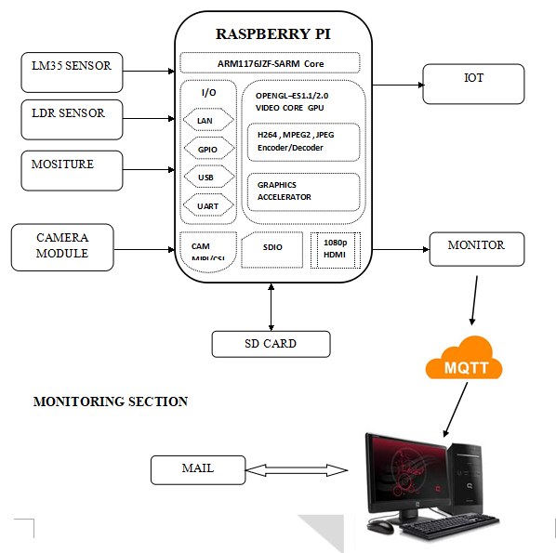

CIRCUIT DIAGRAM
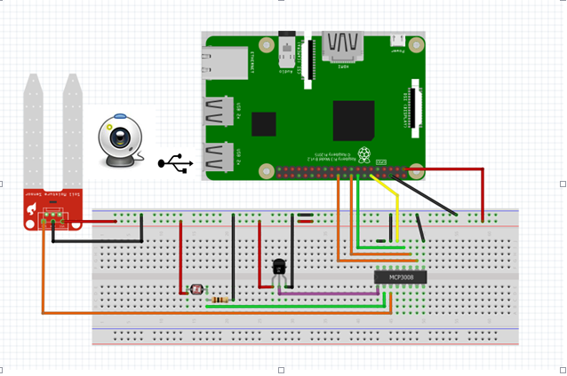

BLOCK DIAGRAM DESCRIPTION
- In this project MCP3008 is used, so connect 3.3v pin from raspberry to all sensors
- Similarly MCP3008 and all sensor’s ground pins should be grounded
- Now connect the sensor’s output pins to each channel of MCP3008 (ex: LM-35 to channel 0, LDR to channel 1 and Moisture sensor to channel 2 of MCP3008)
- Connect USB camera with raspberry pi
- Connect power supply for Raspberry pi
- Plug the HDMI cable in Raspberry pi from the monitor using VGA to HDMI converter cable
- Connect USB Mouse and USB keyboard to the Raspberry pi

HARDWARE REQUIREMENTS
- Raspberry Pi
- Temperature (LM 35)
- LDR
- Moisture Sensor
- Smoke sensor
- MCP3008 (ADC IC)
- USB Camera
- SD card
- Monitor

SOFTWARE REQUIREMENTS
- Raspbian Jessie
- PHP
- MQTT Protocol
- Language – Linux
- Python

RESULT
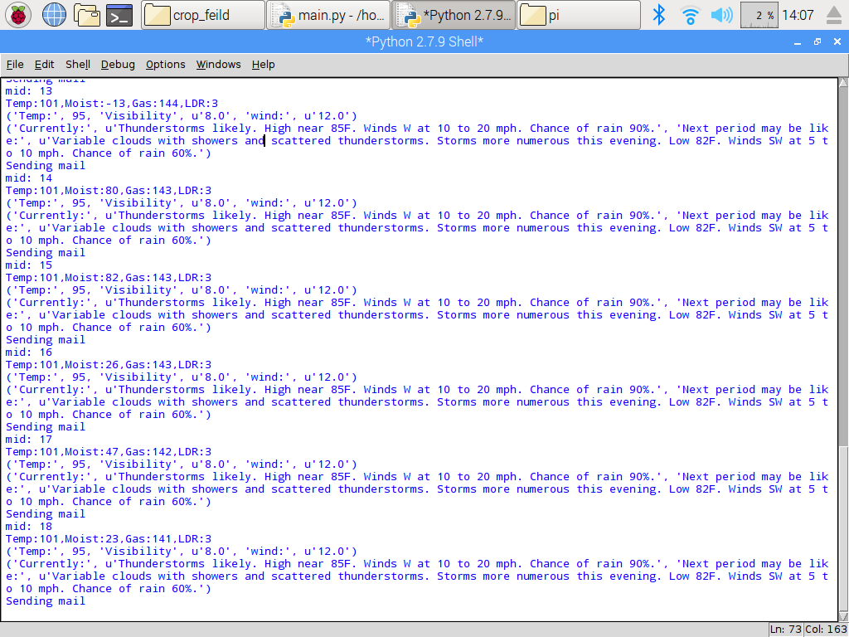
- The above figure shows the output of the sensor parameters as well as the current weather report as well as an upcoming weather report.
- In this system, if there are possibilities of rain, it is intimated through registered mail id (It can be re configurable to any other parameters like a thunderstorm, high temperature etc.)
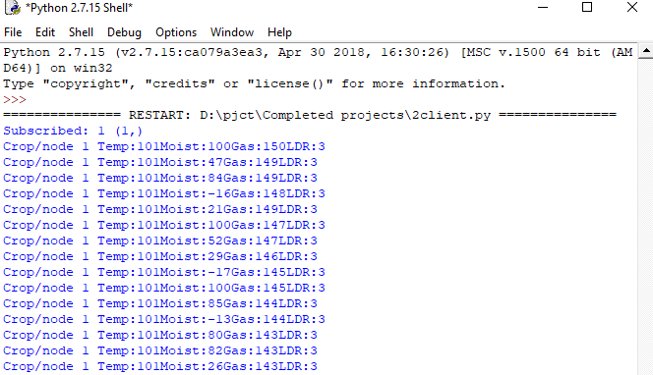
- The above figure shows the output of MQTT clients receiving the parameter values from different sensors.
- Sensors parameters are transmitted to clients using MQTT protocol.
- In the above figure, “Crop/node” resembles MQTT node, by having more clients which are in the same node, multiple data can be received from different clients placed in different areas of fields.

CONCLUSION
According to this system, irrigation system becomes more autonomous with quick transmission of data by using MQTT protocol. The main advantage in MQTT protocol is, even when clients are not in the node network, data will be sent, whenever a client is connected with that node, they can able to see the data which has been sent already. So that they can able to analyze the atmospheric change throughout every day.

