Abstract:
Assistive technologies are being developed for physically impaired people in order to live confidently. This project work proposes a camera-based assistive text reading framework to help blind persons read text labels and product packaging from hand-held objects in their daily lives. The project work is framed into three stages. First, Image capturing – Using a mini camera ,the text which the user need to read get captured as an image and have to send to the image processing Platform. Secondly, Text recognition – Using text recognition algorithm, the text will get filtered from the image. Finally, Speech output - A filtered text will be passed into this system to get an audio output. This project work can be able to insist the blind people in their daily life. The entire application is based on Raspberry Pi.

The Raspberry Pi is a credit card sized single computer or SoC uses ARM1176JZF-S core. SoC, or System on a Chip, is a method of placing all necessary electronics for running a computer on a single chip. Instead of having an individual chip for the CPU, GPU, USB controller, RAM everything is compressed down into one tidy package. Raspberry Pi needs an Operating system to start up. In the aim of cost reduction, the Raspberry Pi omits any on-board non-volatile memory used to store the boot loaders, Linux Kernels and file systems as seen in more traditional embedded systems. Rather, a SD/MMC card slot is provided for this purpose. After boot load, as per the application program Raspberry Pi will get execute.

Existing system:
- Braille display
- Uses only simulation Platform

Proposed System
- Runs on Raspberry Pi
- Text recognition using MATLAB Platform
- Audio output

Block Diagram :
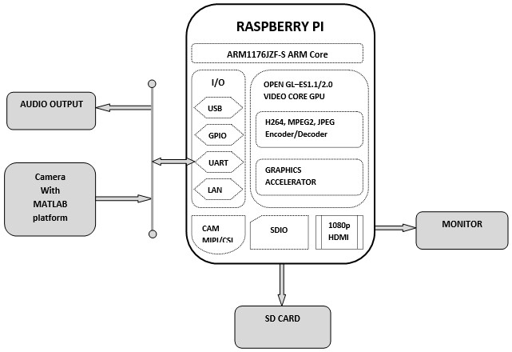

Hardware units:
- Raspberry Pi
- Camera
- SD card
- Monitor
- Audio Output unit

Software:
- Raspbian
- MATLAB
- Language – Linux , Embedded C

