FIFTEEN LEVEL CASCADED MULTILEVEL INVERTER USING 12 POWER SWITCHES

ABSTRACT
This project is based on cascaded H bridge inverter and various topologies. Inverters are mainly used for commercial and industrial purposes. The unique structure of the multilevel inverter is low harmonics in output voltage. There are different types of multilevel inverters. Among these Cascaded multilevel inverters drawn tremendous interest in power industry because it requires less number of components. As the number of level increases the harmonic content of output voltage waveform decreases. This Cascaded H-Bridge fifteen level inverter with minimum number of switches. As the level increases the synthesized output waveform has more steps which produce staircase wave that approaches desired waveform. The problem of switching losses and power losses can be eliminated with minimum number of switches.

INTRODUCTION
Multilevel inverter provides a suitable solution for medium and high power systems to synthesize an output voltage which allows a reduction of harmonic content in voltage and current waveforms. The solar photovoltaic (PV) modules directly converts the light energy into the electrical energy, but energy obtained from the PV module acts as low voltage DC source and has relatively low conversion efficiency. In order to improve the efficiency and convert low voltage DC source into usable AC source, the power electronics converters are used to transform DC into AC.

EXISTING SYSTEM
In normal fifteen level cascaded inverter is required for 28 switches to produce the fifteen level output. And also required for 7 sources.
If 28 switch means the pwm pulses are generates complicated. So this 15 level inverter is used to less number of power switches.

PROPOSED SYSTEM
This project proposed new multilevel inverter with reduced number of switches and the switching losses is also get reduced with reduced total harmonics distortion(THD). And also easy to control the voltage of the multilevel inverter.
BLOCK DIAGRAM
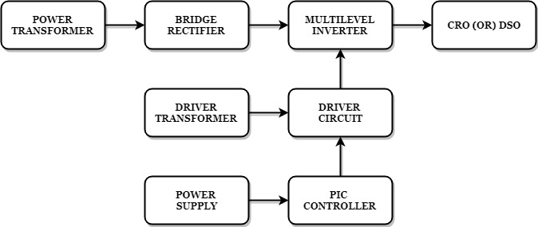
BLOCK DIAGRAM EXPLANATION
- Pulse generator: - Here we have used PIC microcontroller (PIC 16F877A) to make a switching signal.
- Driver circuit: -It can be used to amplify the pulses and provided isolations by using opto coupler. It has two functions,
- Amplification
- Isolation
- Bridge Rectifier: It converts AC to DC Supply.
- Inverter: It converts DC to AC Supply.
DRIVER BOARD
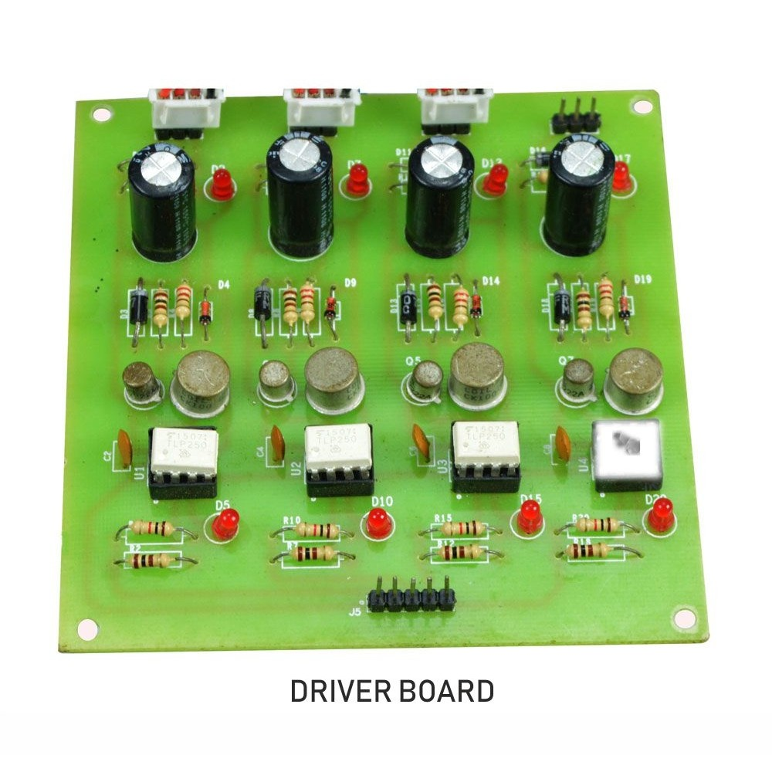
PIC CONTROLLER BOARD
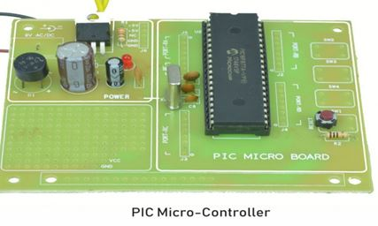

WORKING
The pic controller is used to generate the pwm pulses for converter and inverter circuit. The pic controller pulses are given to the driver circuit as input. Driver board is mainly used to isolate and amplify the input signals from the controller. The amplified driver output will be connected to the main power circuit devices. And the devices are turned on by using the pwm pulses. The power transformer is directly connected to the bridge rectifier. The bridge rectifier converts the ac voltage into dc voltage. Dc voltage is converted into ac voltage by using multilevel inverter circuit. The multilevel inverter output waveform is shown in below.
CIRCUIT DIAGRAM FOR DC TO AC 15Level Inverter
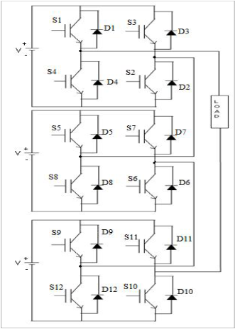
ADVANTAGES
- Reduce the switching loss.
- High efficiency.
- Reduced THD.
- Reduced number of switches.
APPLICATIONS
- Industrial machines
- Automobiles medical equipment
- Household appliances
- Airplanes
- High Power Applications
CONCLUSION
In this project it reduces the uneven degradation of power switches, switching losses when compared to the conventional PWM technique and harmonics are reduced and the output waveform level is increased. And also increase the efficiency.
MULTILEVEL INVERTER OUTPUT
